Procedure of Savings Declaration by Employee Through Work Flow
The new application of Savings Declaration by Employee has been added into Work Flow Application System. The employee would be able to declare all Savings, Interest Income, Income from house Property and Interest on House Building loan , House Rent recipt, Children Tution fee and Interest on education Loan thru this system which will be accepted by Finance user for consideration into Income tax process. Initially all declaration would be posted as proposed by employee which can be changed as Actual by Finance user on verifying the proof of the declaration. Following is the detail of procedure to be followed by Employee to make entry of savings into workflow system.
- Apply New Application in Curent financial year
Login into Work Flow Application System then go to “Application Menu”. Under Application menu another sub menu would appear. Choose Option “Saving Declaration” from submenu. The next Form appears where Financial year would be displayed. Click on the Financial Year , the system displays the main savings declarion Screen

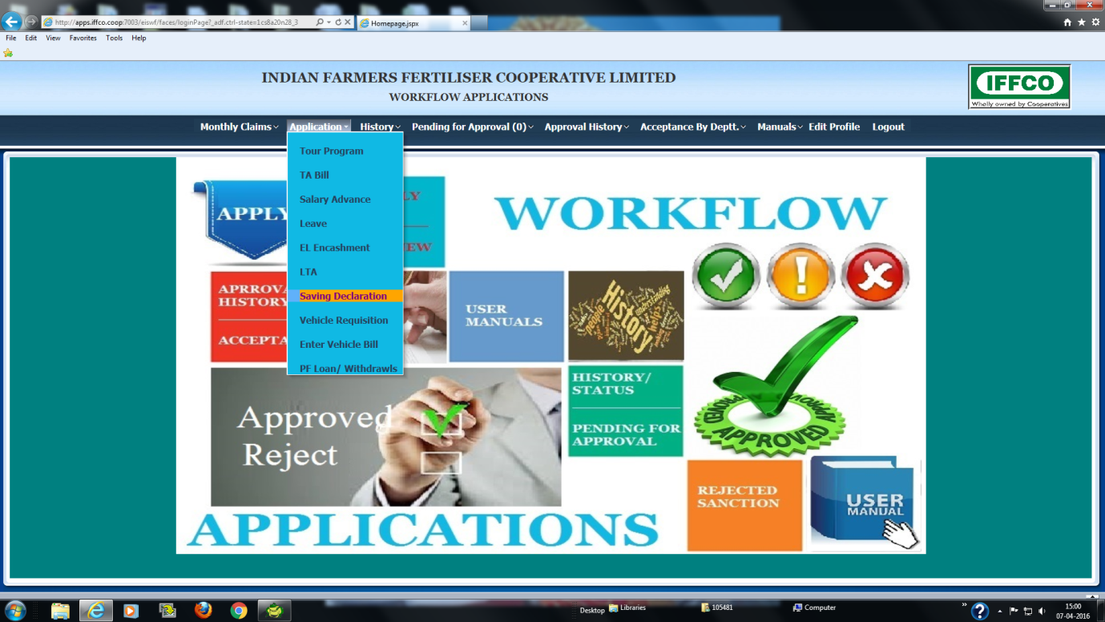

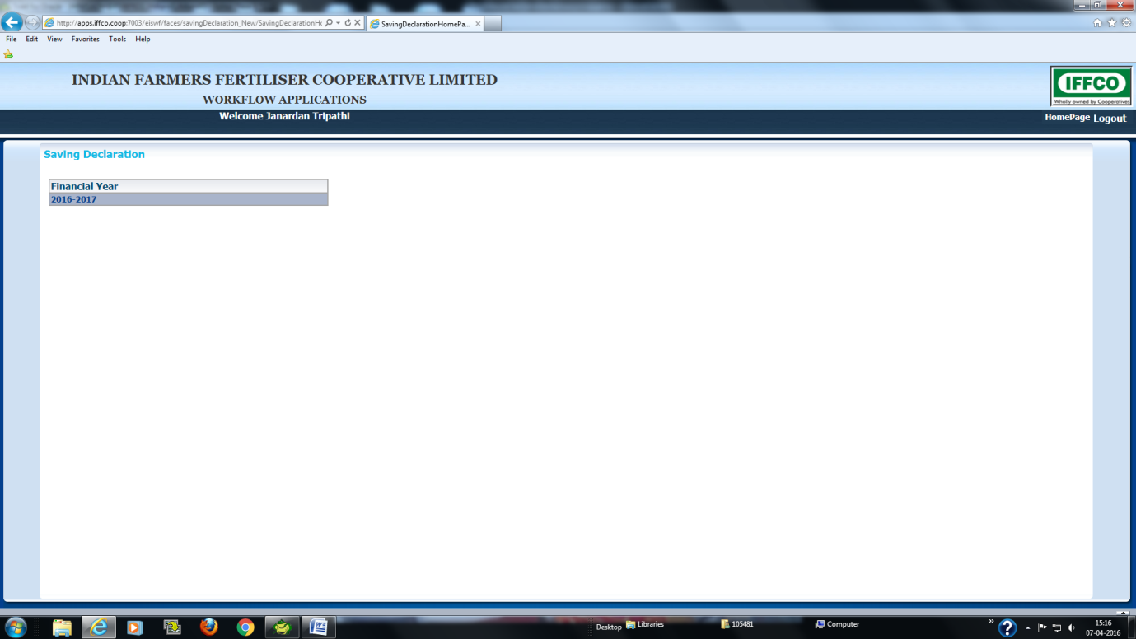

- The main Savings declaration Forms would display employee’s details in the top as it displays in all other work flow application. The system creates a blank work flow document for Savings declaration to be filled by employee.
- The Form has been divided into several pages. Employee has to click the page to open corresponding form for the entry. The Form also contains Buttons such as “Save & Exit”, “Submit”, “Cancel” at bottom of each page. Initially the application is created in draft mode. If the employee do not want to make entry in the form then can click “Cancel” Button to go back to previous stage.
- Employee is supposed to keep all relevant documents in hand before initiating the application so that necessary data is readily available for entry. Sitting idle for long time may disconnect the session. However if employee wants to save the partial data and submit the application later may press “Save & exit”.
- The first page of the application is “Savings” . The employee can choose the Scheme under which he has made the savings from List and make an entry for proposed savings. Each saving will be stored as “Proposed”. The finance will verify the each declaration and after receiving the relevant document make it Actual.
- The second page is “Other Income”. Here employee can declare Interest Income from Fixed Deposit and SB Account and any other non salary income.
- The third page is “Income from house Property”. Here Employee can declare the Income from house Property and also the declare Interest paid on House building loan on the same Property . This Page has three Data entry block. In the first Block Property detail is entered, In the Second block Loan detail is entered and in Third block Income from the House property is entered. Employee can also declare second House Property. For this press “Add Detail” in the first block. The Employee has to declare house income and loan detail against each property separately.
- The fourth page is “House Rent declaration”. Employees who are staying in rented accommodation may declare the Rent paid by him. This declaration is considered for calculation of exemption against HRA Income.
- The Fifth page is “Children Tuition fee”. Here employees whose children are studding may declaration the tuition fee being paid by employee. This entry is considered as Savings under sec 80C as well as for Exemption under chapter VI.
- The sixth page is “Monthly recovery Advice”. Employees who wish to advise Payroll to recover certain amount from salary under “VPF” or “LIC Pension fund” may make entry for the same. The system would automatically recover the entered amount from salary every month.
- The seventh and last page is “Higher education Loan”. Here employee may declare the amount paid as interest against Education loan .
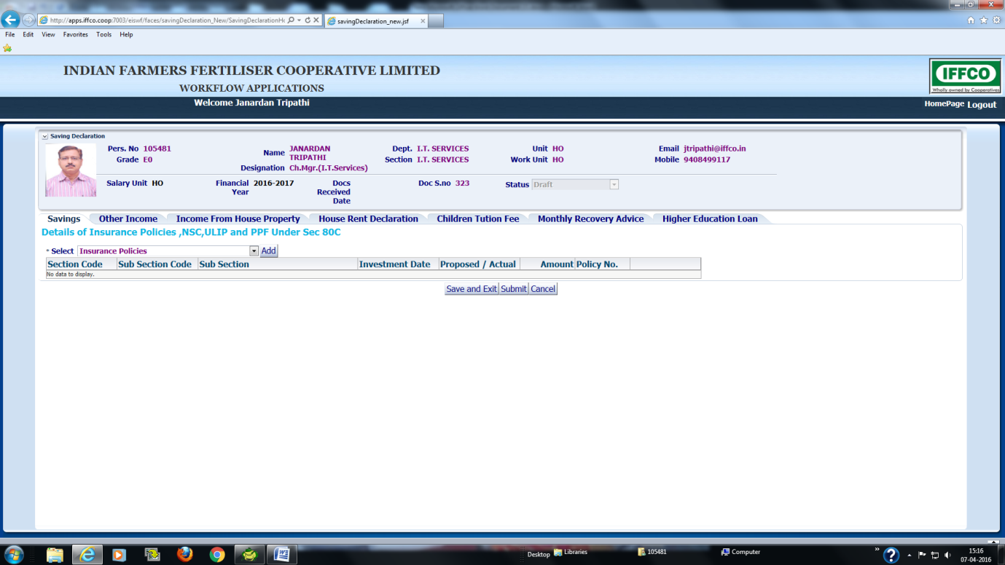
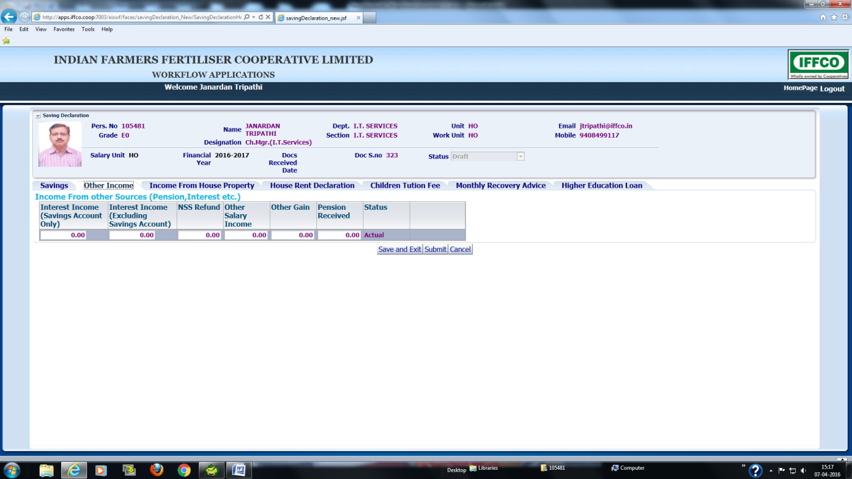
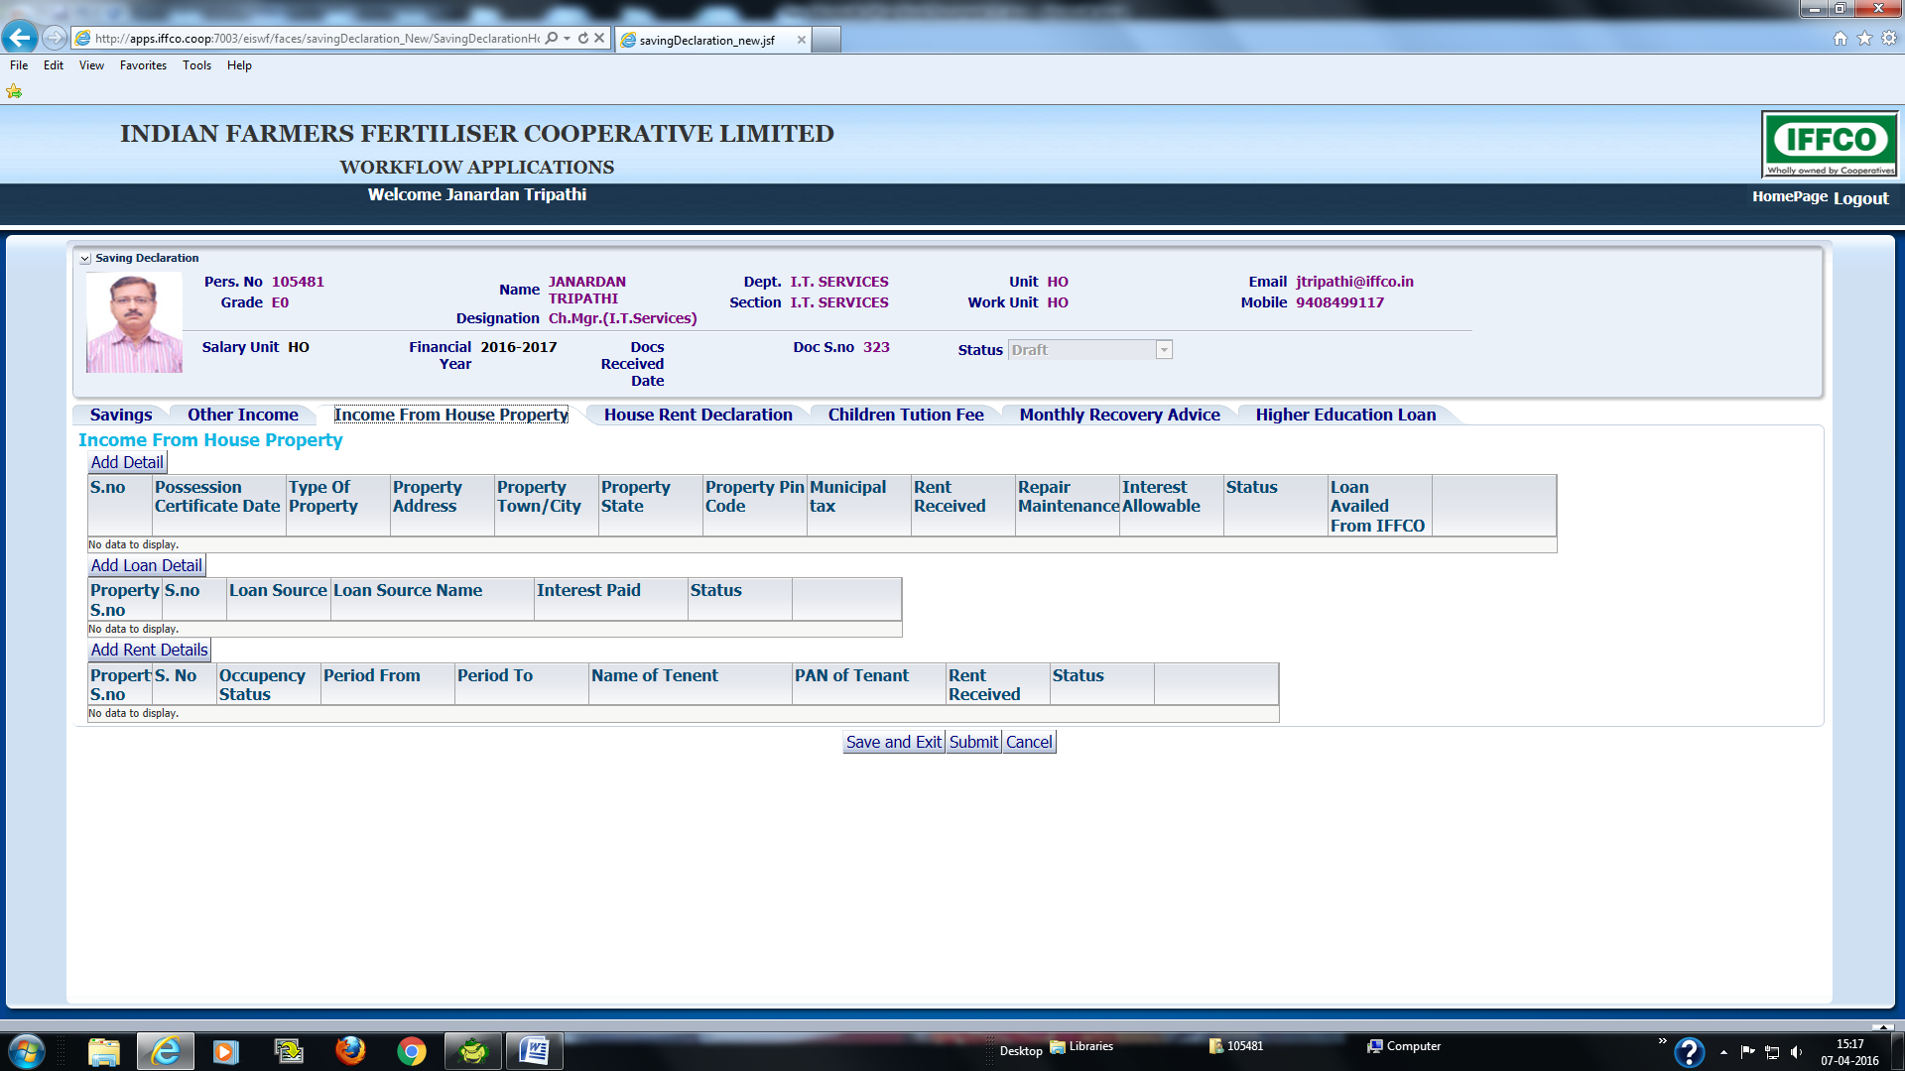
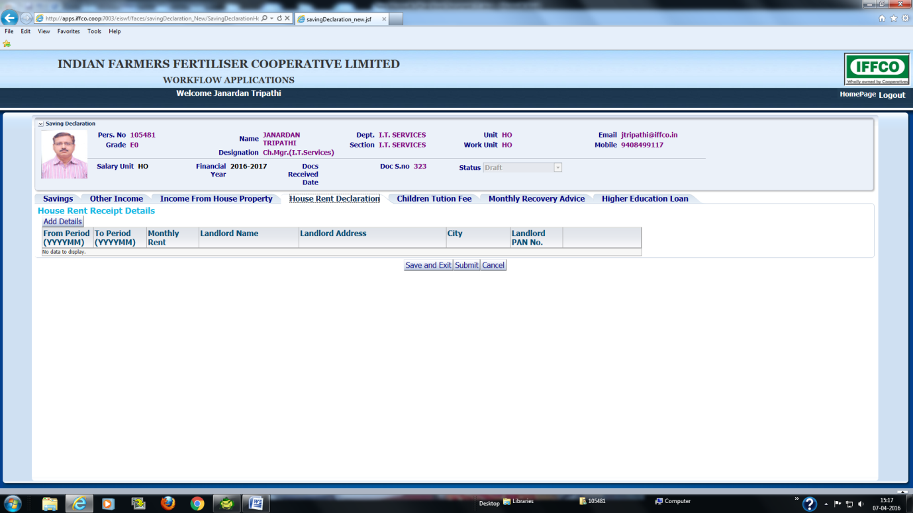
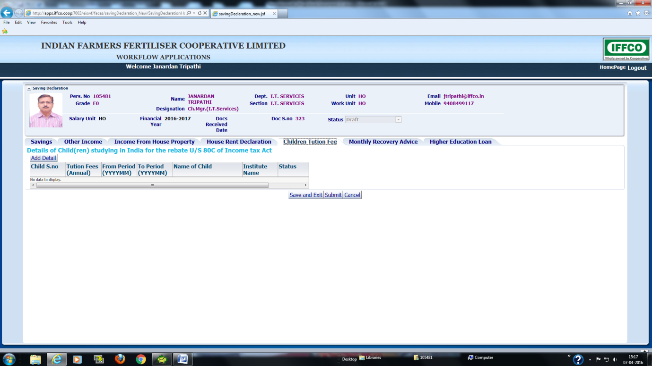
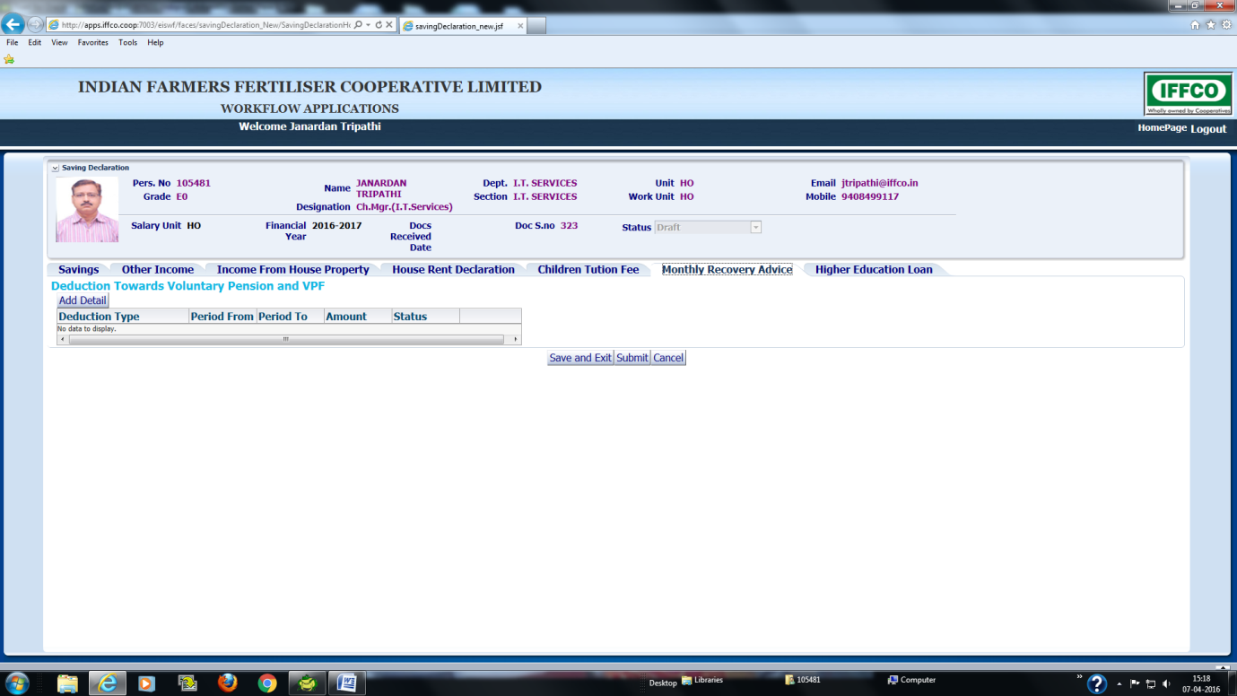
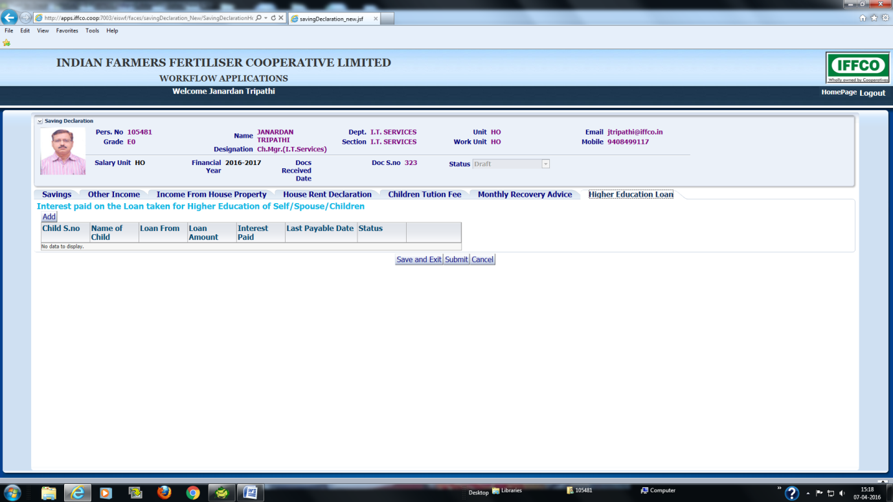

- After completing the entries in all pages employee will press “Submit Button”. After application is submitted it will appear in the screen made for Finance user for further processing and consideration into system . After this Employee would Again Open the Savings Application available under “History” menu. Here “Print” button will be enabled to allow Employee to print the complete Savings declaration . The employee would print the application, sign it and send it to finance along with all other Savings Proofs (Receipt etc).
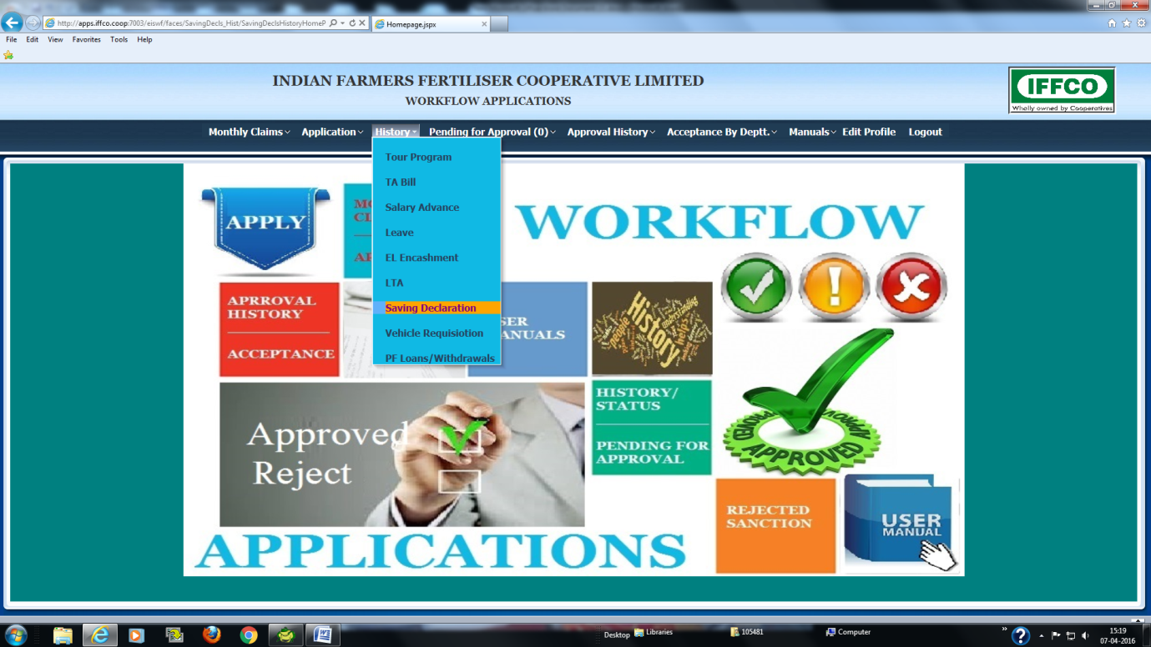

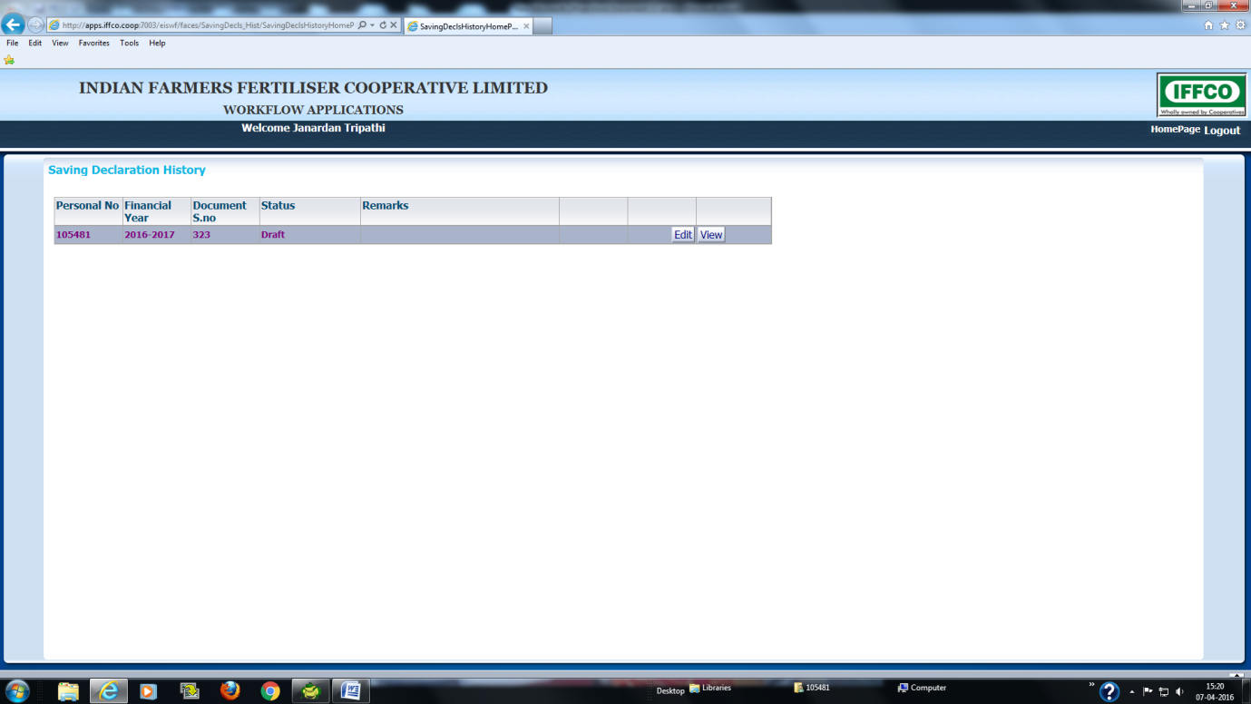
Following is the procedure to be followed by Finance user to accept the Work Flow Application
The Savings declaration application submitted by employee would appear to Finance user for verification in another form. The finance user may go to this form by choosing the “Savings Declaration” option available under “Accept By Department” menu. The screen will display all pending applications in the First Block under “Saving Declaration process”. Here the Finance user would open the application by clicking the Personal No. The complete data of savings declaration submitted by employee would appear in the same form which was available to employee for entry but Finance user would be allowed to change only proposed or actual flag of each declaration. The Finance user will check for each entry and verify from the receipt sent by employee. In case receipt of the declaration is obtained , Finance user will make that entry as Actual. Once each and every entry is checked the user will Press “Accept” Button. At this stage the Savings declaration entries are copied into HRMS for consideration of Payroll and Income tax calculation Process later.

