IFFCO EMPLOYEES’ UNION, PARADEEP UNIT
IEU ELECTION 2015-2018
PDP/IEU Election/ 2015 Date : 17.08.2015
NOTICE
The following is the constitution of IFFCO Employees Union, Paradeep Unit for the period 2015-2018.
POST | NAME S / Shri | Pers.No. | Section | Mobile No. | Photo
PRESIDENT | Tusar Ranjan Samantray | 108394 | F&A | 9437669184 | 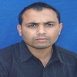
WORKING PRESIDENT | Ajay Kumar Ojha | 108016 | Electrical | 8658461414 | 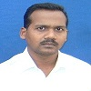
VICE PRESIDENT | Dilip Kumar Bugata | 107818 | SAP(Mechanical) | 9777872525 | 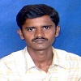
GENERAL SECRETARY | Tripti Ranjan Pohan | 108643 | DAP(Process) | 9937438376 | 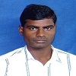
JT.SECRETARY | Nathuram Swain | 108976 | P&A(Medical) | 9937148497 | 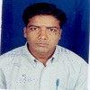
ORGANISING SECRETARY | Subrata Kumar Behuria | 108162 | Offsite(Mechanical) | 9938507258 | 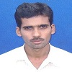

PUBLICITY SECRETARY | Ratnakar Biswal | 107726 |  | DAP(Mechanical) | 9937339889 | 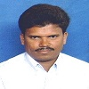
TREASURER | Ramesh Chandra Munda | 108141 |  | Power Plant | 9437668881 | 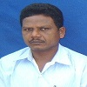
EXECUTIVE MEMBERS
Exec. Member Const. No. 01 | Sudhansu Samal | 107851 |  | PAP(Mechanical) | 9937892008 | 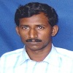
Exec. Member Const. No. 02 | Aurangzeb Khan | 108168 |  | SAP(Mechanical) | 9078228100 | 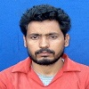
Exec. Member Const. No. 03 | Prasanta Kumar Acharya | 107735 |  | PH(Matrl Hand.) | 9937762598 | 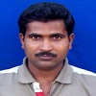
Exec. Member Const. No. 04 | Prabir Kumar Pradhan | 108823 |  | SAP(Process) | 9437317344 | 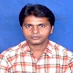
Exec. Member Const. No. 05 | Gobinda Sethi | 108246 |  | Electrical | 7750068071 | 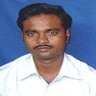
Exec. Member Const. No. 06 | B K Sahoo | 108705 |  | Power Plant | 9938637034 | 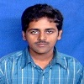
Exec. Member Const. No. 07 | Rashmi Ranjan Mohapatra | 108006 |  | DAP(Process) | 9937972215 | 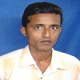
Exec. Member Const. No. 08 | Pabitra Kumar Biswal | 107849 |  | DAP(Mechanical) | 9439468861 | 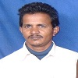
Exec. Member Const. No. 09 | Pradipta Kumar Swain | 109379 |  | CWS(Mechanical) | 9861454984 | 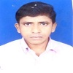
Exec. Member Const. No. 10 | Raj Kumar Prasad | 107553 |  | E&PC | 7873519023 | 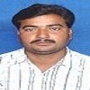
Exec. Member Const. No. 11 | Narasingha Nath Mishra |  | 107962 | Time Office | 9438524972 | 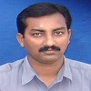

This is for kind information of all the Union Members.

S R Maurya S L M Warrier Manoranjan Mohapatra
Election Coordinator Election Officer Election Officer

Copy to : SGM,Paradeep – FOR KIND INFORMATION PLEASE.
GM(Matls)/OSD/All JGMs/DGMs/SHs
Dy Labour Commissioner/DLO
Notice Board

