Following validation are enforced in the requisition creation process to control the procurement of min max controlled general stock items. Screen shot of advisory is also attached with each one.
- Stock of other unit to be shown to the indenters while creating requisition.
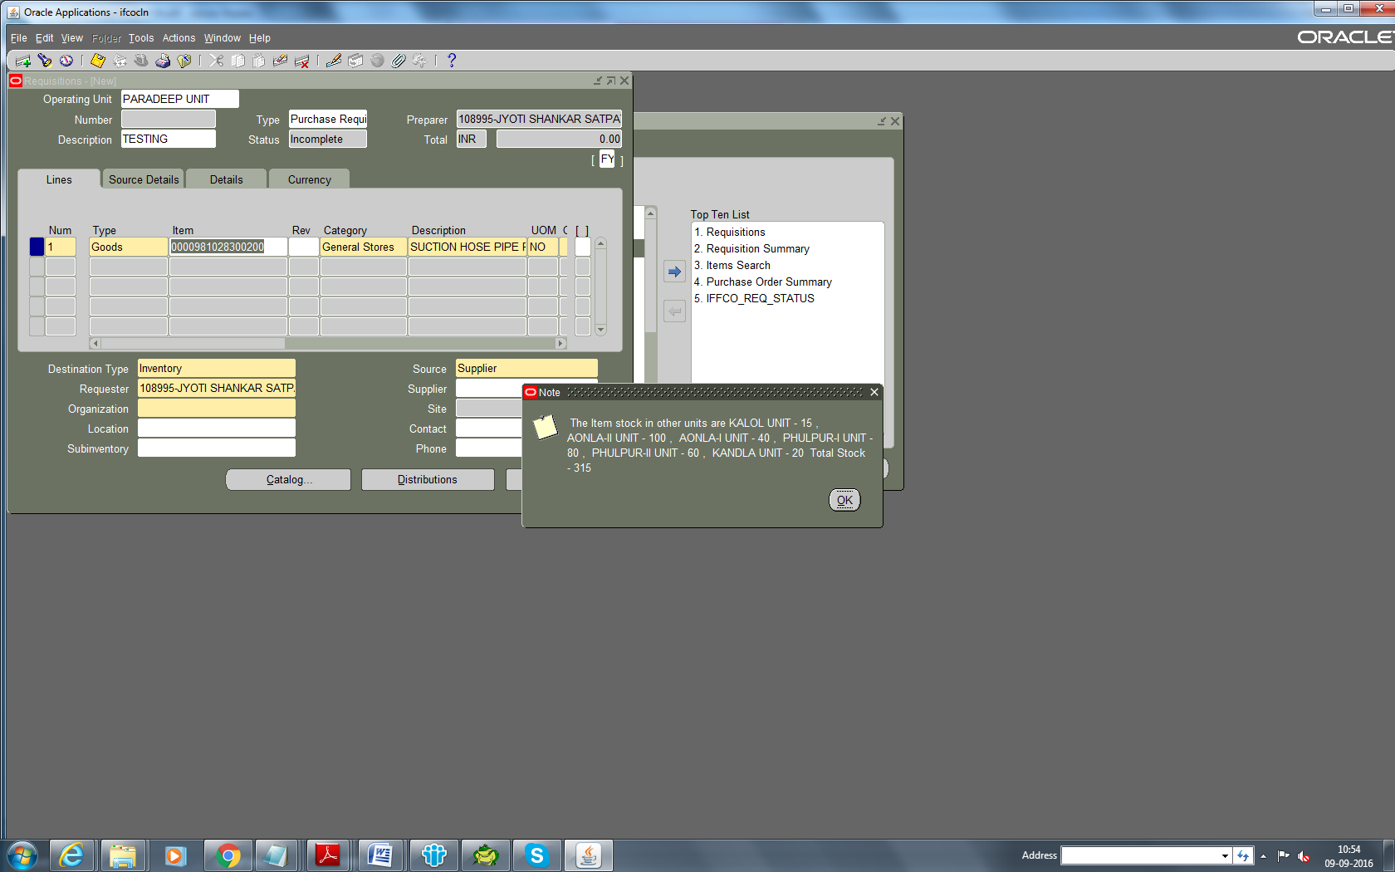

- Stock of other units is now visible to forwarding and approving authorities in the approval path for new requisitions created for their review.
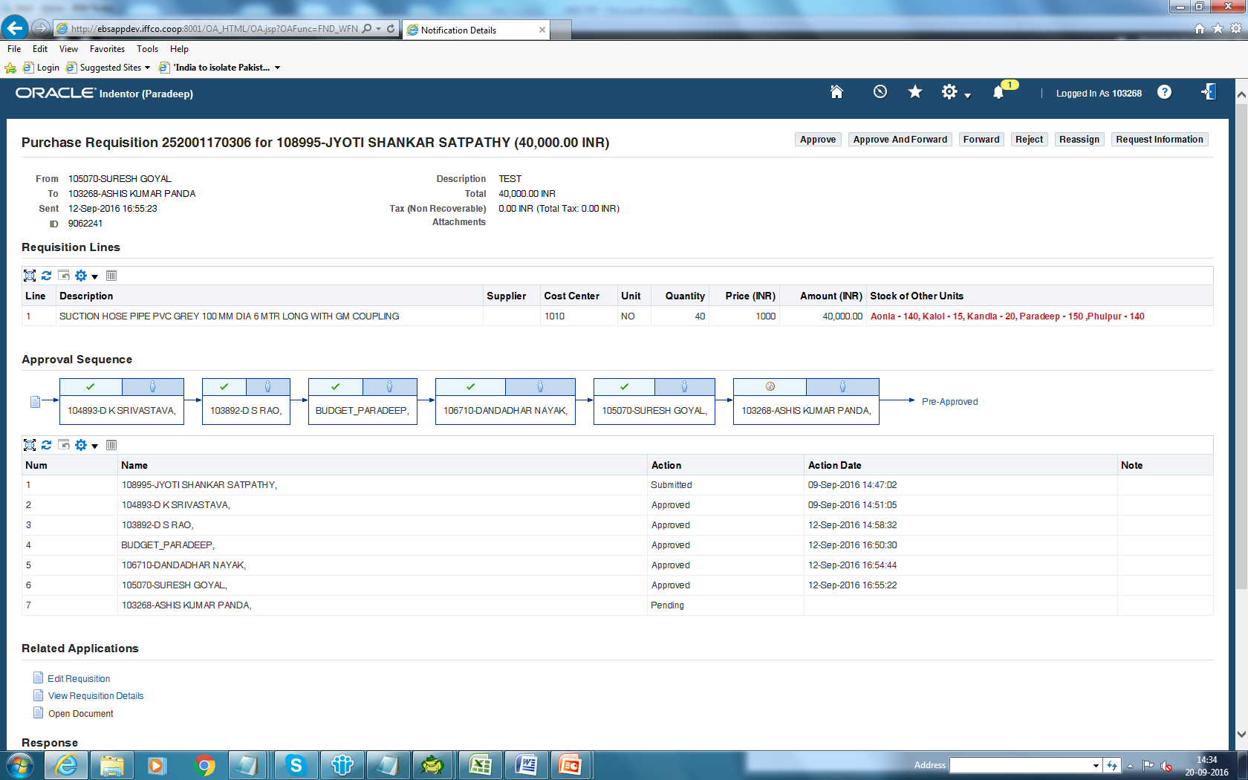

- Global Maximum is maintained for each stock item. For this purpose Max of the master org item has been updated with a value equal to sum of Max of all the orgs.

- Indent is now disallowed for Min-Max controlled general stock items where Requisition qty + On Hand Stock(unit) + Pipeline Qty(unit) exceeds the Max qty at the OU level.

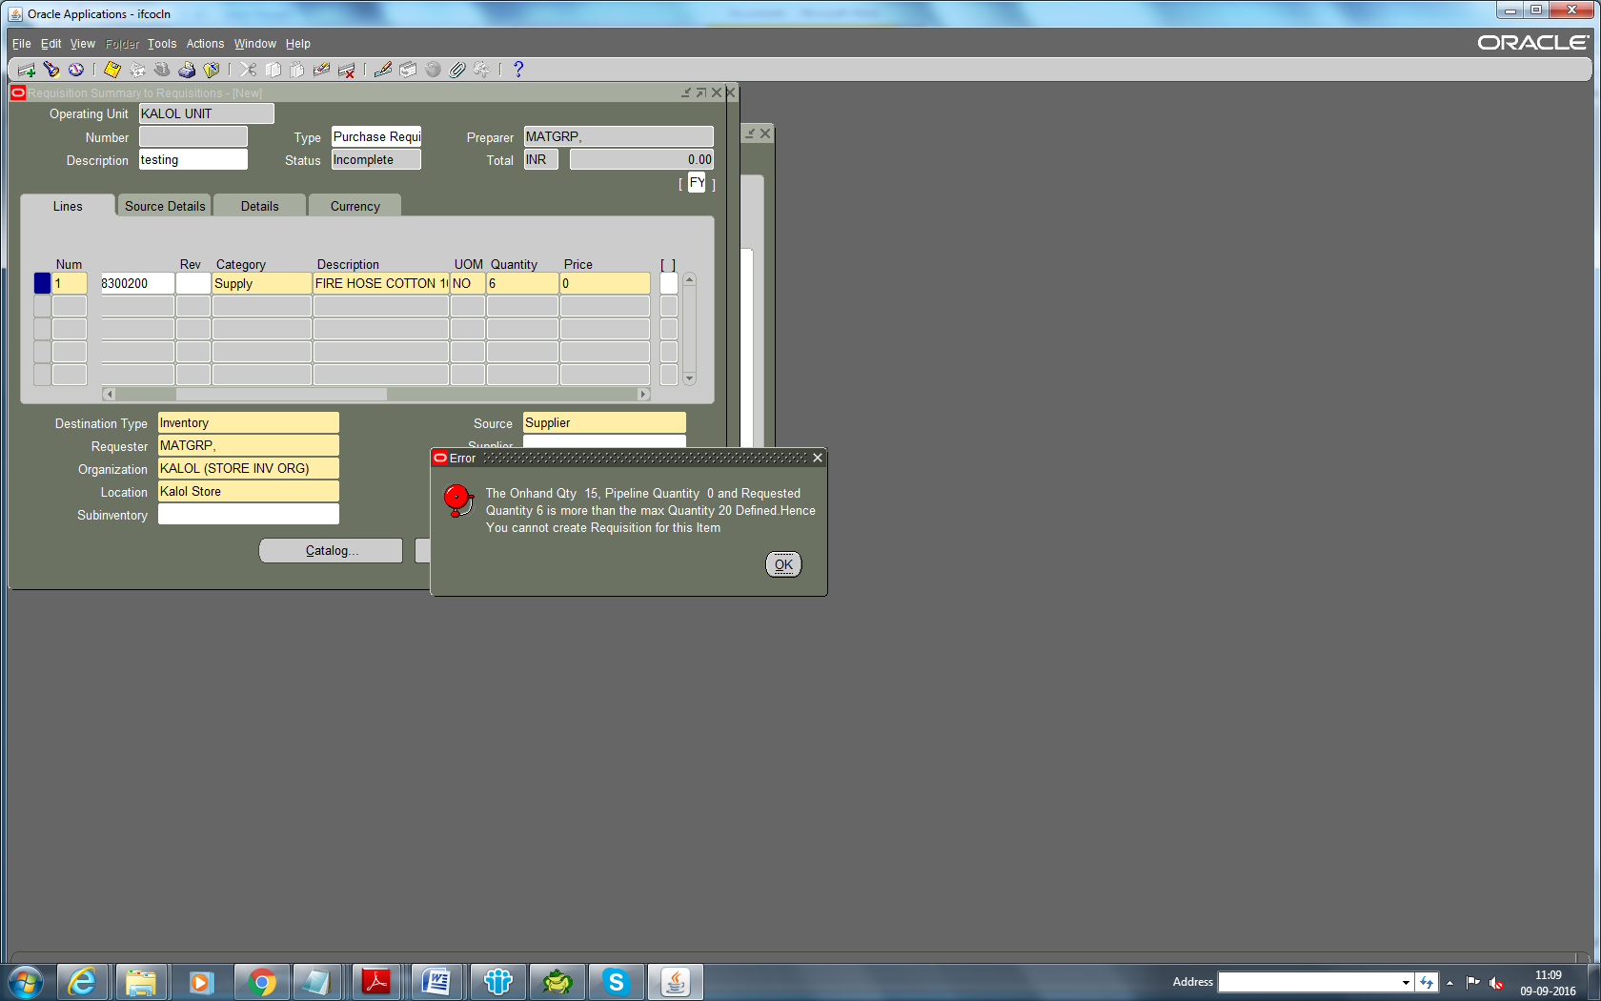

- If validation 4 is cleared and the Requested Qty + (Total Pipeline Quantity + Total available stock) across IFFCO exceeds the Global Maximum defined in the master org then indent can be saved but needs to be approved only thru hierarchy having unit head as topmost approver. For this purpose we have created addition position hierarchies for Stores users as UH – Stores – Unit (Ex – Unit as 2010,2020,2030,2040,2050,2510,2520 for respective units). Users need to select hierarchy starting with “UH -“ for such approvals. Additional position hierarchy required by plants for other departments raising the indents for min max controlled items may be created in the unit itself. While creating such position hierarchy local system department may review the position hierarchy created for stores users of the units. 