GENERAL INFORMATION ABOUT THE IFFCO QUIZATHON 2017

QUIZ POSTER/BACK DROP

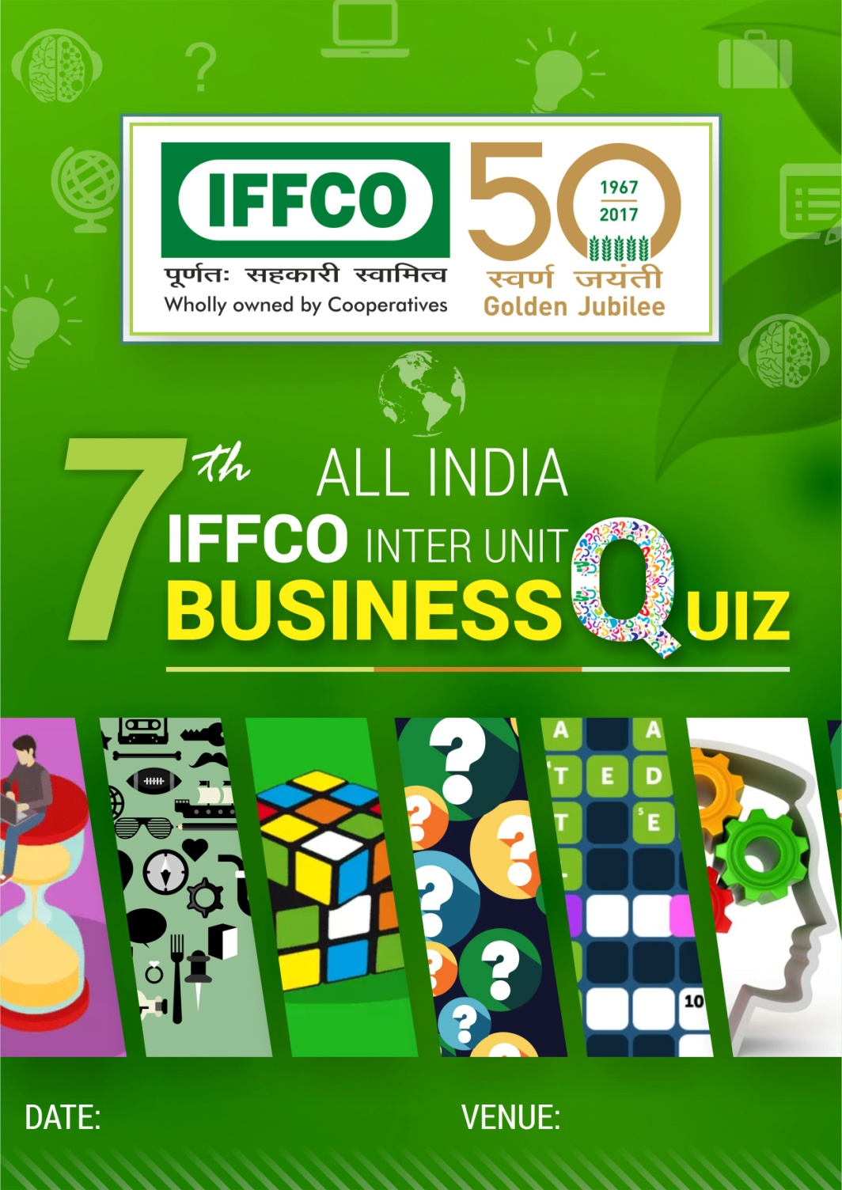

The venue and date may be inserted at your end.

STAGE SETTING FOR 6 teams in the PRELIMINARY ROUND and 7 teams in GRAND FINALE

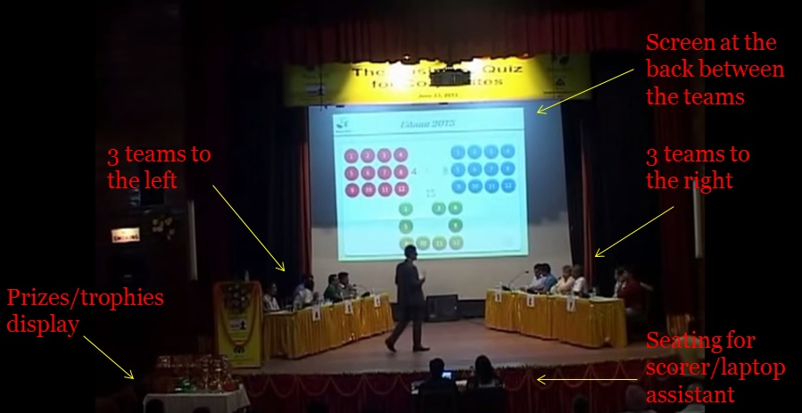

AUDIO VISUAL & OTHER REQUIREMENTS ON STAGE

- ONE MANUAL SCORER from Unit itself.
- 2-3 volunteers for audience prize distribution as well as other assistance.
- Projector + Screen + Audio Input for laptop + speakers/sound system
- Microphones (6 for teams + 1 cordless for Quizmaster)
- 2 plug points with 3 pins each for Laptop charger and buzzer
- Backup laptop with MS Office 2010 (or higher version) installed
- Good Sound System

QUIZ SCHEDULE
SCHEDULE OF PRELIMINARY AND GRAND FINALE
PARADEEP UNIT – PRELIMS | 13th NOVEMBER, 2017
HO/MKCO - PRELIMS | 15th NOVEMBER, 2017
MARKETING FIELD OFFICES | 16th NOVEMBER, 2017 (written only)
KALOL UNIT – PRELIMS | 21st NOVEMBER, 2017
KANDLA UNIT – PRELIMS | 22nd NOVEMBER, 2017
AONLA UNIT – PRELIMS | 27th NOVEMBER, 2017
PHULPUR UNIT - PRELIMS | 29th NOVEMBER, 2017 (PRE-LUNCH)
GRAND FINALE AT PHULPUR UNIT | 29th NOVEMBER, 2017 (EVENING HRS)

QUIZ TIMING*
The quiz timings will be as under:

UNIT | PRELIMS (WRITTEN) | ON-STAGE PRELIMS
PARADEEP | 1000 HRS | 1130 HRS
HO/MKCO | 1200 HRS | 1400 HRS
MARKETING FIELD | 1500 HRS. | Not Applicable
KALOL | 1000 HRS | 1130 HRS
KANDLA | 1000 HRS | 1130 HRS
AONLA | 1000 HRS | 1130 HRS
PHULPUR (PRELIMS) | 0900 HRS | 1030 HRS.
PHULPUR (GRAND FINALE) |  | 1400 HRS.

*the timings can be changed as per the local requirement. The proposed change, if any, should be conveyed to HO well in advance.

TRAVEL PLAN OF QUIZZER MR. AJAY POONIA
The travel tickets are appended with this mail. Arrangements may be made by respective unit for commutation of the quizzer Mr. Ajay Punia (Mobile 9968329111) as well as guest house accommodation.

FORMAT OF PRELIMINARY ROUND
Maximum number of teams may be encouraged to participate in the preliminary round. It will be held in two stages:

- Prelim written Round
- On-stage Prelim – 6 ROUND Questions.

On the basis of marks scored in the Prelims (Written) by the teams, 6 highest scoring teams will be selected to contest in the on-stage prelim event at each Unit.

Only the First and Second high scoring teams in the Prelims (On-stage) will qualify for the Grand Finale at Phulpur Unit.

FORMAT OF GRAND FINALE
Two teams from each Unit (i.e. 14 teams/28 participants from 7 Units of IFFCO) i.e. Kalol, Kandla, Phulpur, Aonla, Paradeep, HO/MKCO, and Marketing Field will contest in the Grand Finale which will commence with written round and based on the marks scored, 7 teams will finally contest in the Grand Finale (On-Stage). It will have 8 ROUNDS.

The on-stage event will include direct questions with/without options, options, buzzer/fastest finger first round, rapid fire, audio-visual etc. etc.

AUDIENCE DURING ON-STAGE QUIZ
All the Units should ensure that the on-stage prelims at all Units and Finale at Phulpur should be attended by large number of people from among the employees as well as their spouse, children and dependent parents. This will be a morale booster for the participants as well as the quizzer.

PRIZES
For Preliminary Round:
The six teams qualifying for the on-stage round in the preliminary round at respective Unit should be given book by Mr. Satya Nadella titled ‘HIT REFRESH’.

For Final Round:
The prize details shall be communicated to Phulpur Unit separately.

Audience Prizes:
Sufficient number of audience prizes (chocolates, lays, pens, mugs etc. etc should be procured for the audience. The person(s) among the audience giving right answer will be given prizes by the quizzer.

ARRIVAL OF PARTICIPANTS AT PHULPUR FOR GRAND FINALE
The finalists from all the seven Units should reach Phulpur Unit on 28th November, 2017 by evening.

They will be taken to Varanasi for sight-seeing on 30th November 2017.

The return journey can be planned on 30th by night train or next day depending upon the availability of train or flight.

QUIZZER PROFILE
Ajay Poonia is the co-founder of www.qryptiq.com (pronounced like cryptic), a content and marketing company.
Quizmaster
He has been hosting quizzes for over 7 years for several corporates, PSUs, colleges and TV channels. Some of his clients include- ITC, SAIL, Powergrid, Engineers India Ltd, TATA Steel, Hero MotoCorp, HPCL, JSPL, Honda, JSW, Maruti Suzuki, IIM-Calcutta, ISB, IIT-Roorkee, IIT-Indore and many more.
TV Anchor
Known for his entertaining and engaging delivery style, Ajay has hosted 4 seasons of a quiz show for school children on TV18.
Author
Ajay has authored a series of GK Books for classes 1-8, Quizcraft used by over 2200 schools across India.
He has also authored an Indian heritage quiz book for CBSE, New Delhi.
Apps
He has also worked on building some widely popular trivia apps on iOS and Android with combined downloads of over 10 million like QuizDesi, Trivia Crack, Quiz Adda etc.
Editor
He was the Editor of a popular online knowledge magazine for children – KnowQout.
He is also associated with two YouTube channels focusing on education –
1. Unstammer – Learn pronunciation of English words
2. Factidious – Unearthing some incredible stories and presenting them in a short and crisp manner

====================================================

