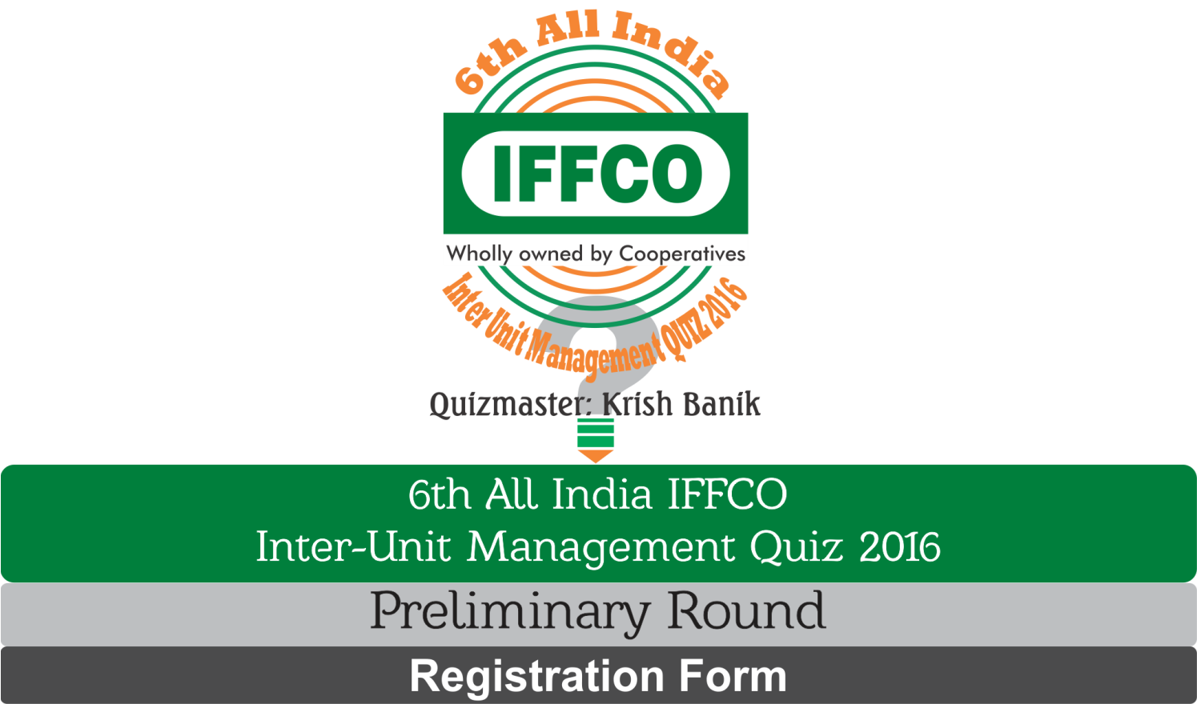
We would like to participate in the preliminary round. Our particulars are as under:
 | TEAM MEMBER 1 | TEAM MEMBER 2
Name
P.No.
Designation
Unit/Place of posting
STATE/AREA Office (in case of Mktg. employees)
TELEPHONE NO. (with Code)
MOBILE NO.
EMAIL ID
SIGNATURE

