A new method of copying requisition is illustrated below. The exact copy of old requisition is created with new requisition No. Later the new requisition can be opened in requisition screen and modified as desired.
Steps:
- In indentor responsibility, iProcurement Home menu is added . Click on it.

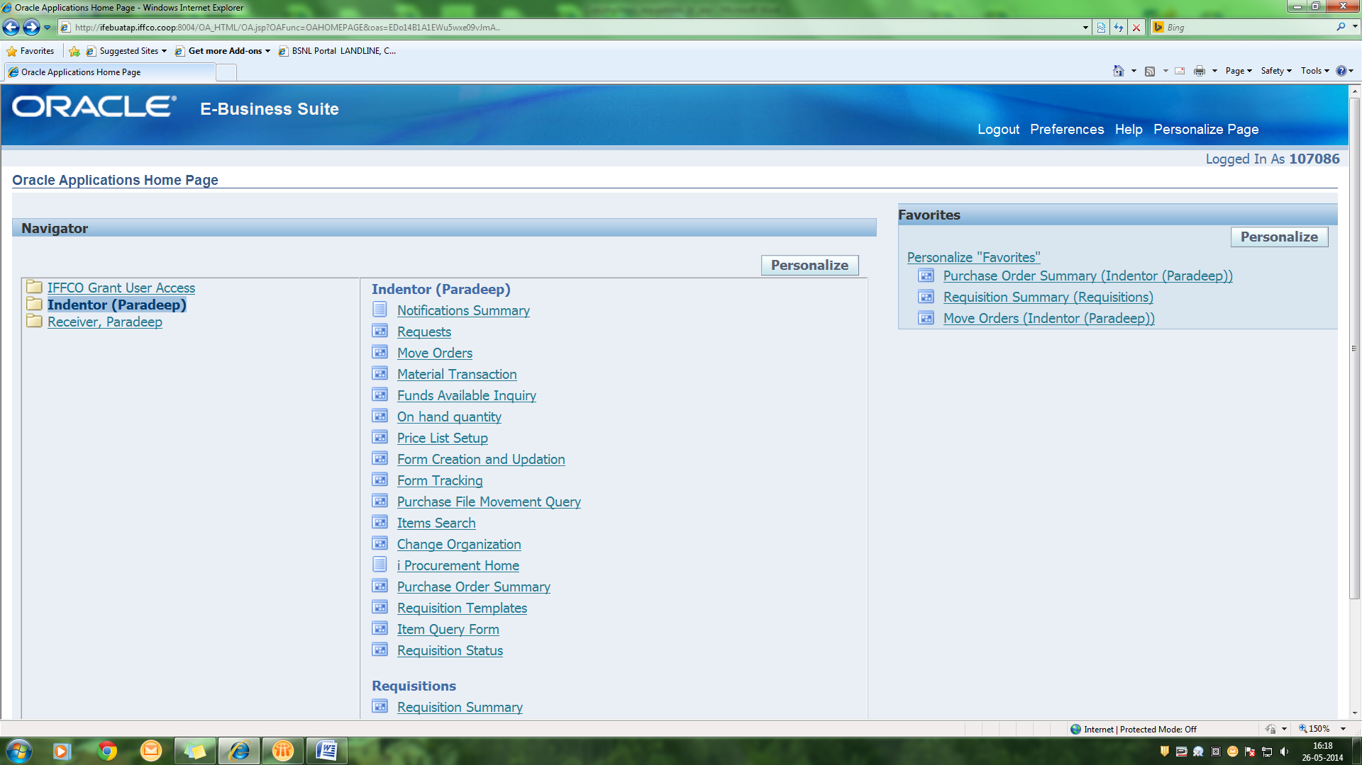

- Requisition Home Page is opened. This page shows some requisitions by default. If your desired requisition is available, click on <Copy> link against the requisition and then go to step 4 otherwise go to step 3.

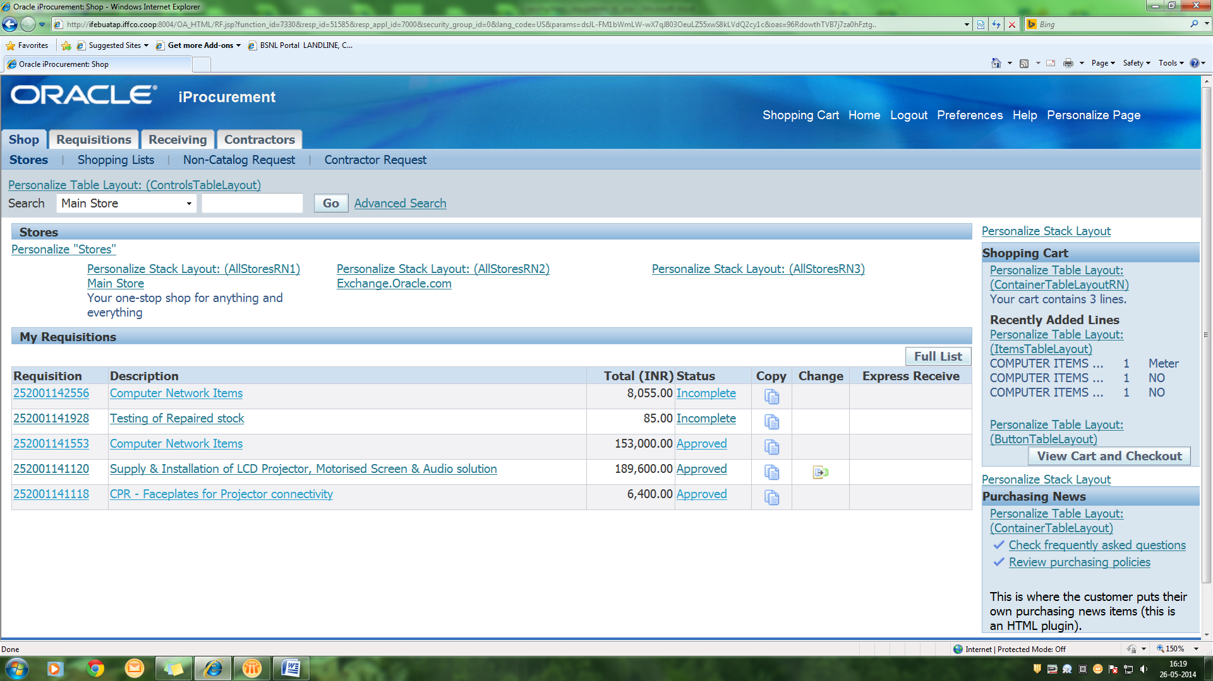

- Click On <Full List> button to see complete list. Search & Select the requisition to be copied. Click on <Copy to Cart> Button
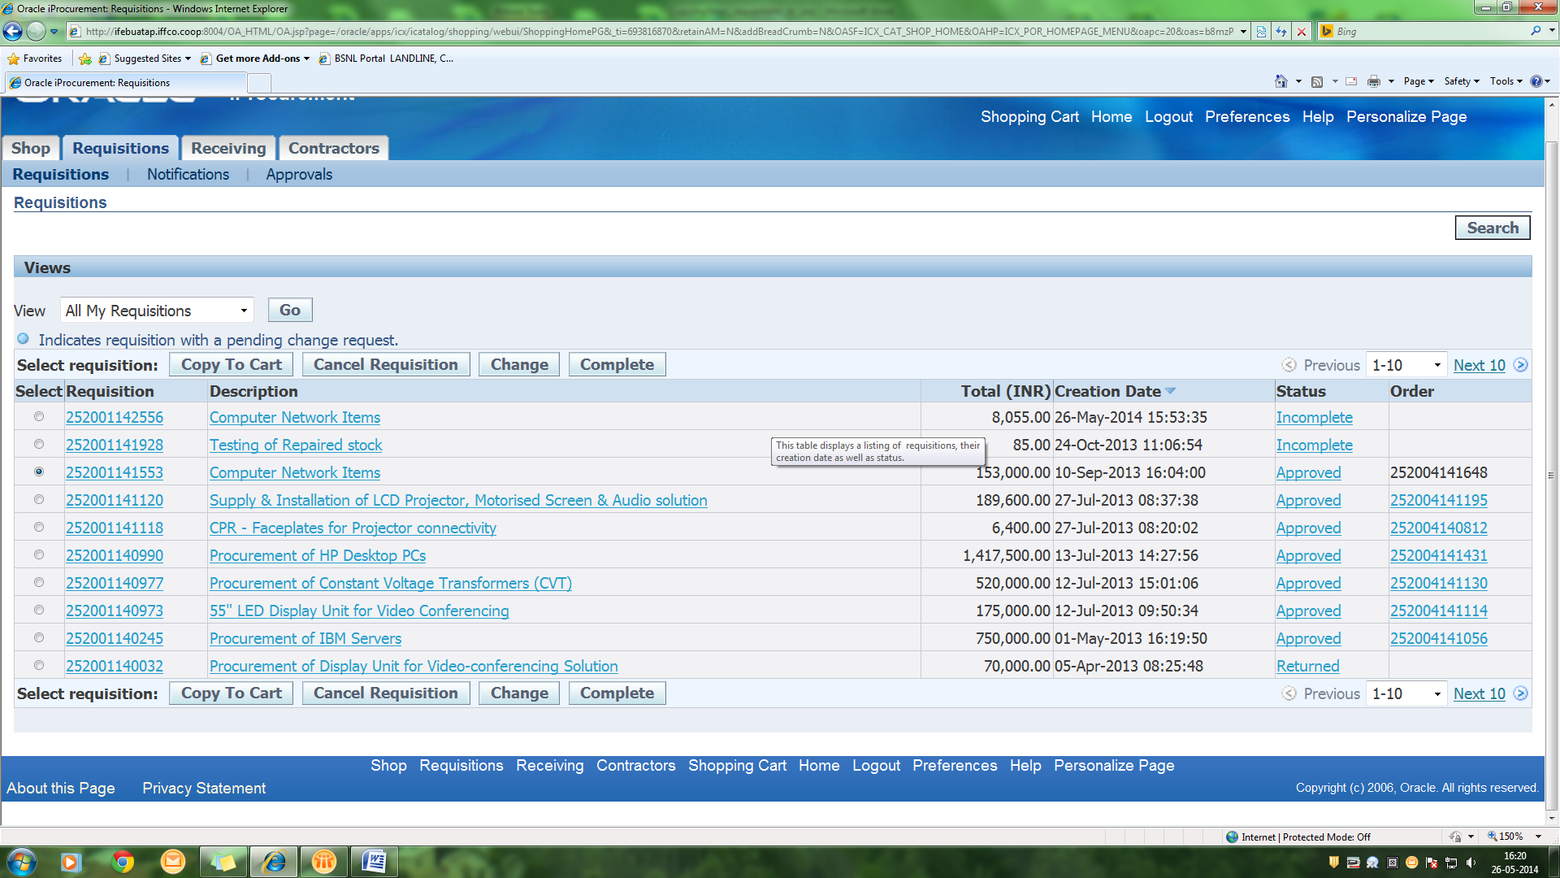

- A Shopping Cart page is opened and all the items of that particular Requisitions are added. Items that are not needed can be removed here by clicking on trash icon on the extreme right side. Once done, Click on <Save> button.
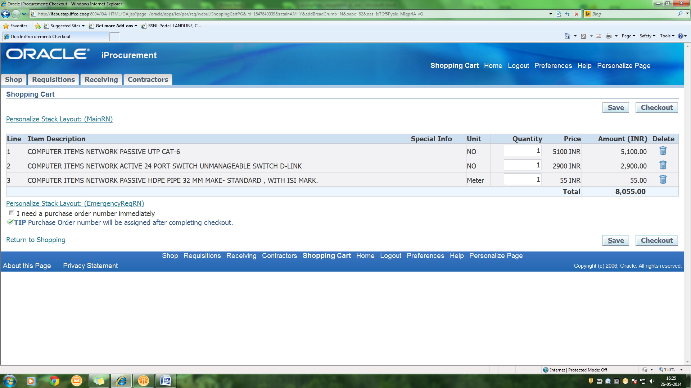

- Confirmation page comes. Note down the requisition No. and click on <Home> link to close the page.
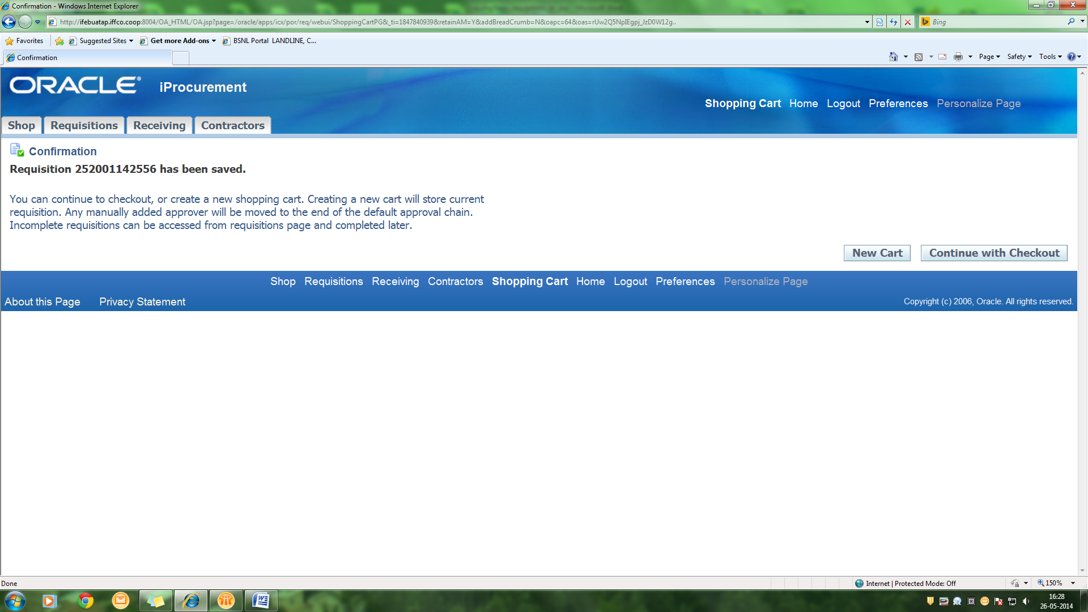

- For editing the new requisition created, query the requisition in Requisition Screen as shown below. Review the Financial-year , Budget-codes , Supplier-list etc if needed, in Header DFF.
- Also review the GL-date , charge account etc if needed , in Distributions of each Lines.

