IFFCOApp Installation Manual

- For Android Users :
For Android phone the App is available in google play store with the name IFFCOApp or you can use the following link
https://play.google.com/store/apps/details?id=com.company.IFFCOCorp

- For iOS Users:
IFFCOApp now is not available on Apple Store. It is to be downloaded / updated locally as per the details given below.

- Steps to install IFFCOApp on iPhone / iPad for first time without AppStore

1. Goto https://bidr.iffco.coop/iosAppLink from Safari Browser of your device.
2. Click on the IFFCO logo as shown in the fig below
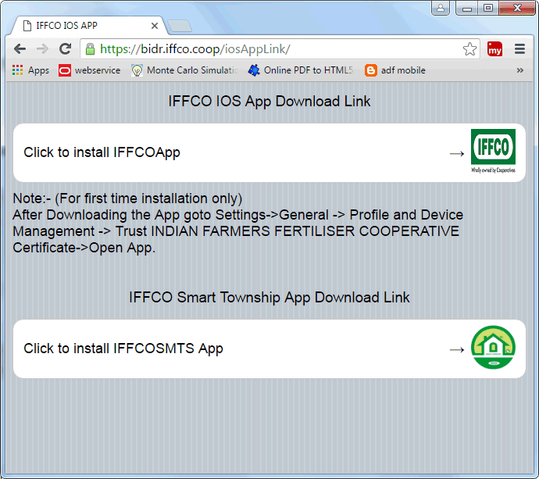
3. You will see an icon in your applications having title loading.Let it download completely.
4. If you are installing App first time,you have to trust IFFCO certificate.Steps are as under:

i. Goto Settings of your iPhone or iPad.
ii. Goto General and then Profile and Device Management
iii. You will see a certificate as INDIAN FARMERS FERTILISER COOPERATIVE
iv. Trust the certificate.
5. Now your App is ready to use.

B. To update the app ,

1. Open the following link in your iPhone’s Safari Browser

https://bidr.iffco.coop/iosAppLink/

2. The following page will open

3. Click on the IFFCO logo to install the app.

