CONGRATULATION TO PARADEEP UNIT
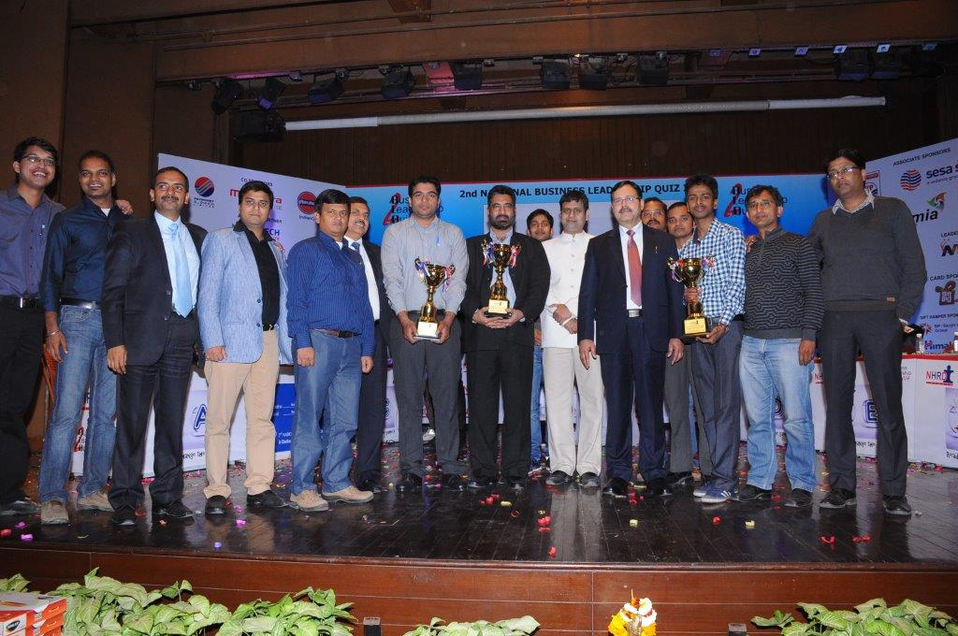
It is a matter of pride that two teams from Paradeep Unit had entered the final round of the NHRDN 2nd National Business Leadership Quiz 2014 after winning the prelims held in Kolkata. The Final Round Quiz took place on 8th February, 2014 in New Delhi in which the IFFCO Paradeep team consisting of Mr. Vipin Pourush, Asstt. Manager (GE) and Mr. Akash Behera, Sr. Engineer (P) secured 2nd position (Runners up) while Mr. Dhiren Kumar Jena, Manager (P) and Mr. Arun Kumar Behera, Dy. Manager (Mech), Paradeep Unit, stood fourth. Teams from corporate giants like SKF, Stock Holding Corporation of india, Honda, GENPACK, Indian Oil, NTPC, Bharat Petroleum, Luxor, Hindustan Petroleum, Coal India, DS Group, ICICI Bank etc participated in the quiz. The prelims were held pan India in Mumbai, Pune, Bangalore, Kolkata & Delhi. The Quiz questions were good blend of trivia from HR, Marketing, Business & Advertising domain. The TCS team maintained lead since the beginning and emerged as winner. NHRD Network is an autonomous professionally managed organization, playing a catalyst role in grooming Leaders for Tomorrow.

