Please perform the following operations from any user for which the error is displayed on the home page.

1. Login with user ID and password
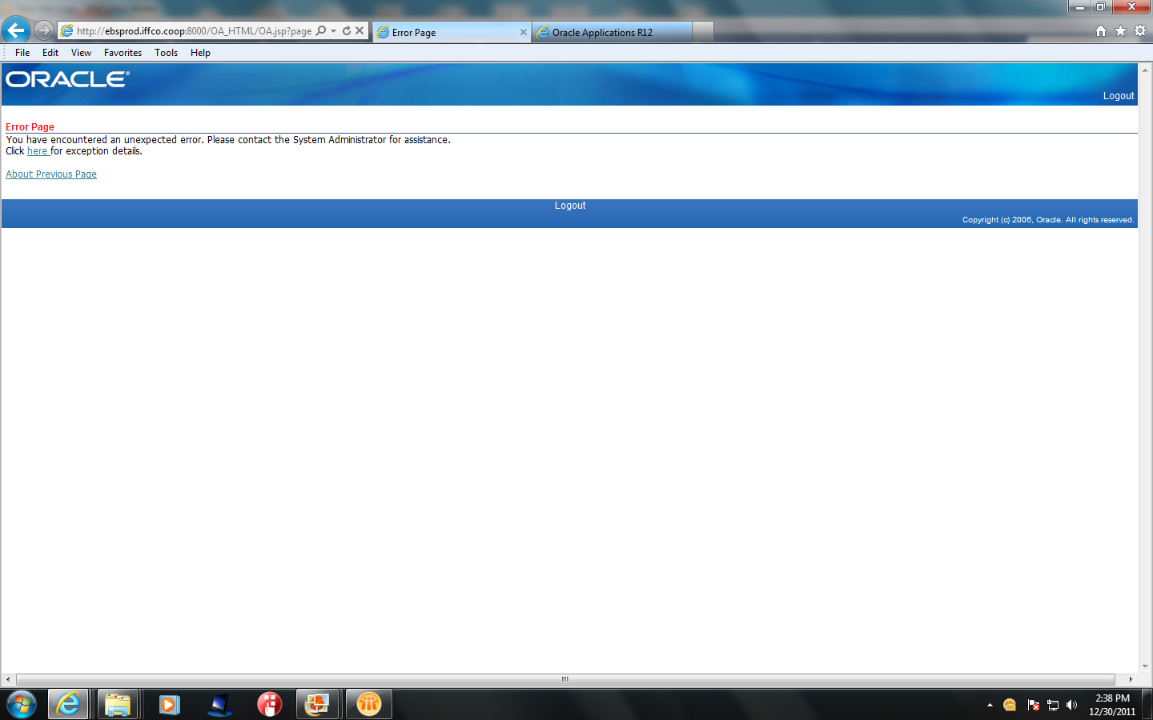

2. Press About previous page
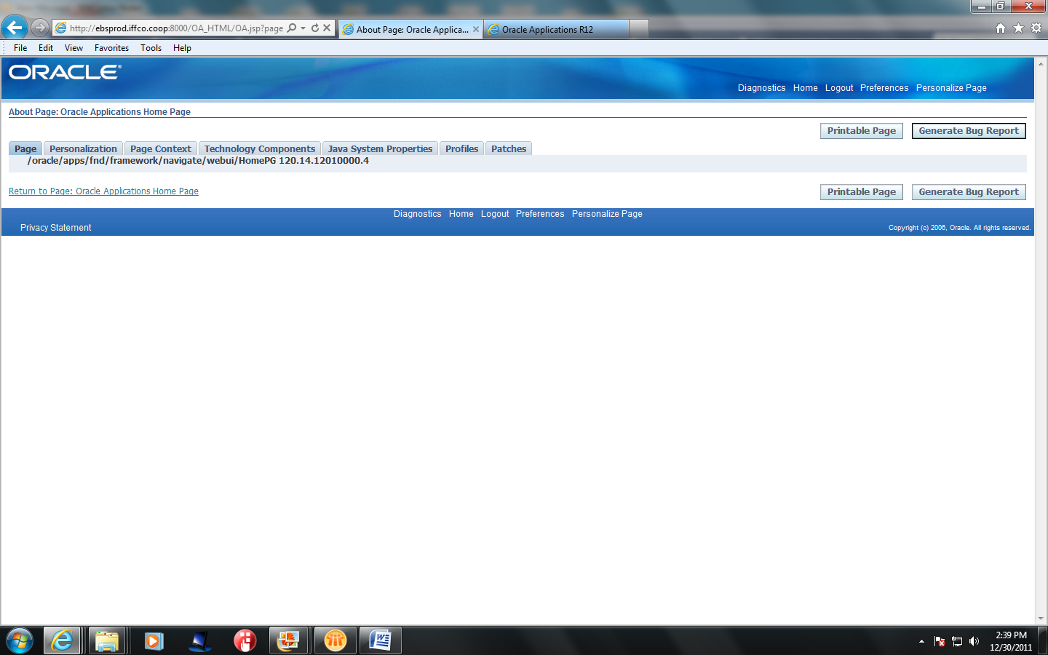
3. Go to Preferences
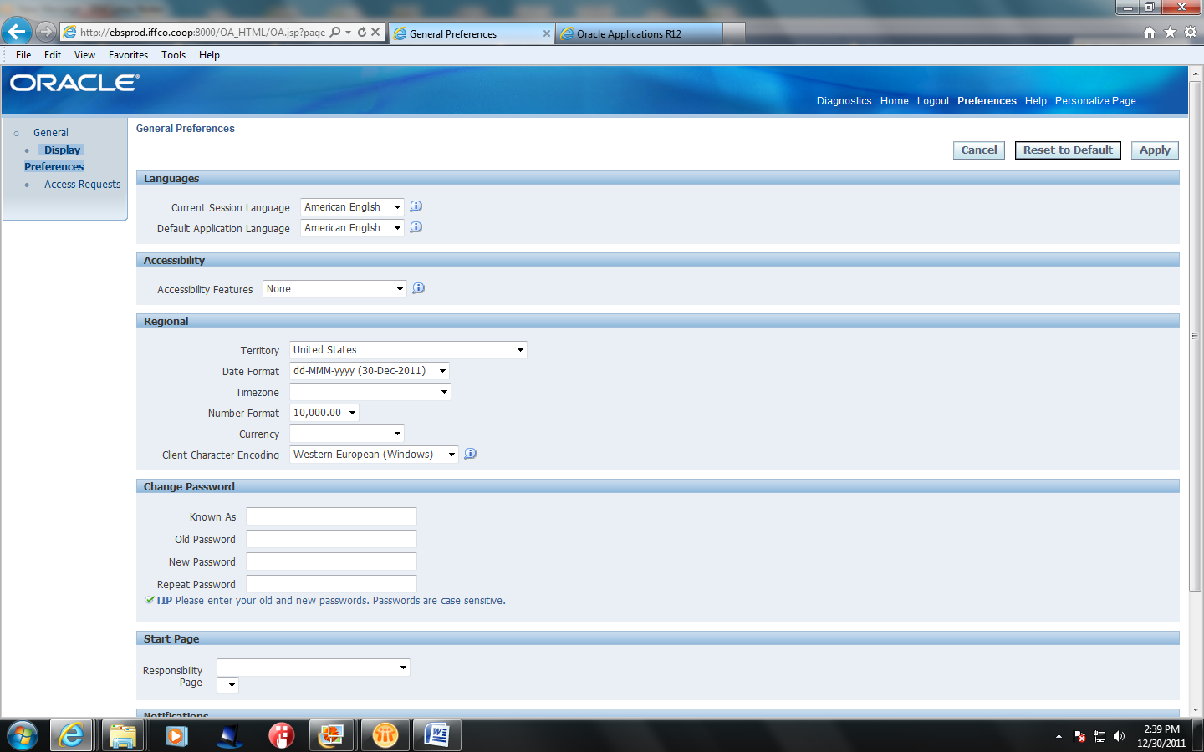

3.Select Any Responsibility under the Start Page Section in the page

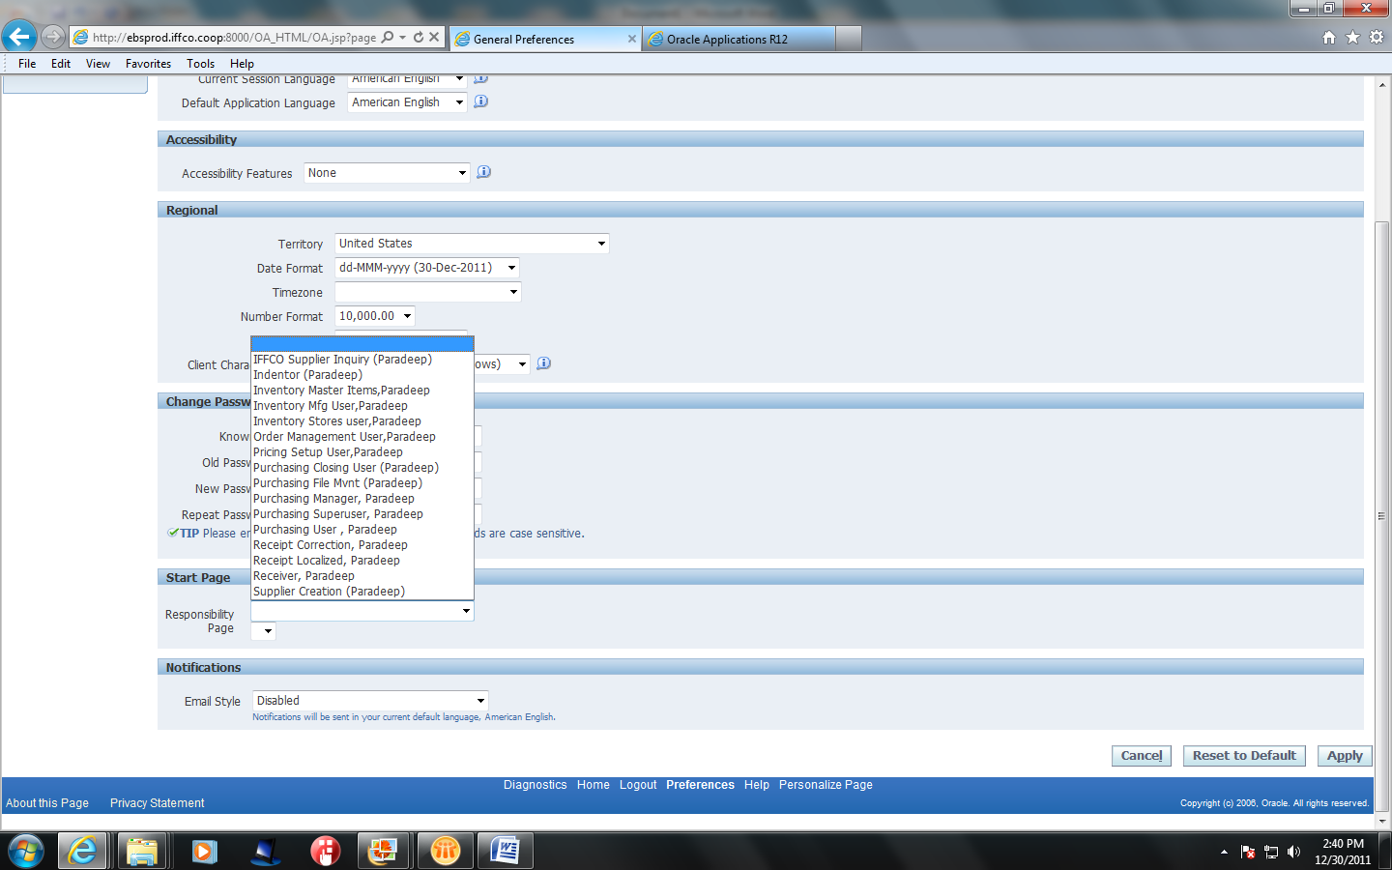

4. Select the Page in the Start Page Section
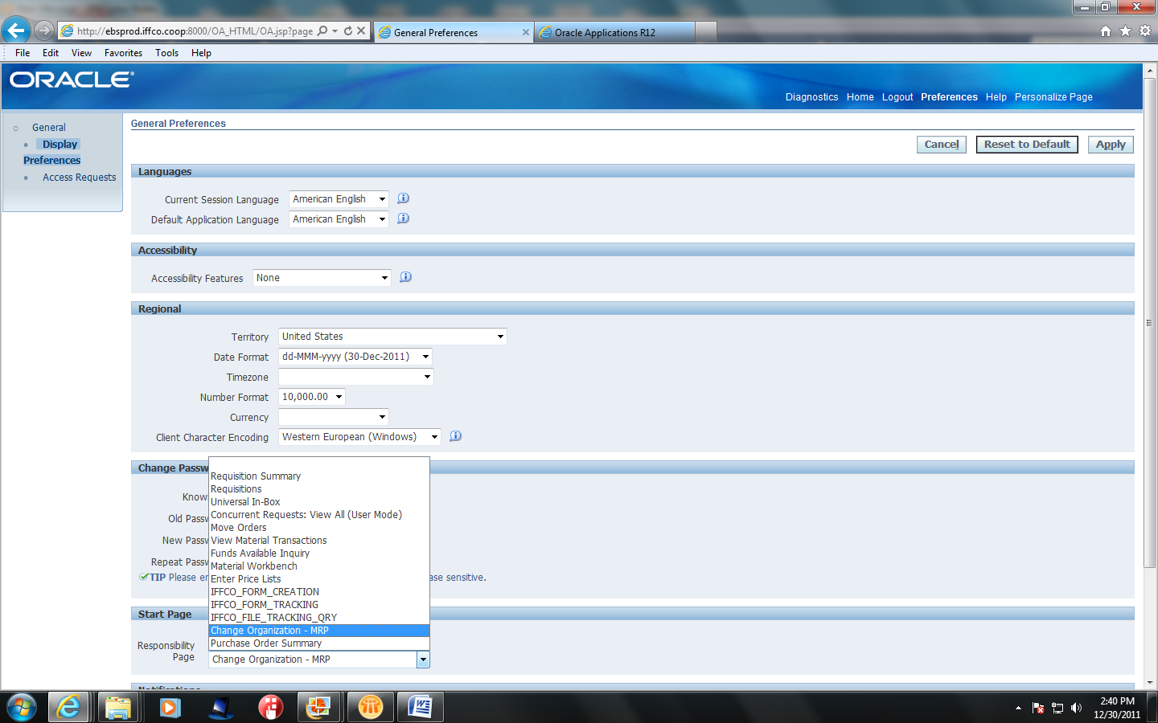
5. Press the Apply button in the page displayed below.
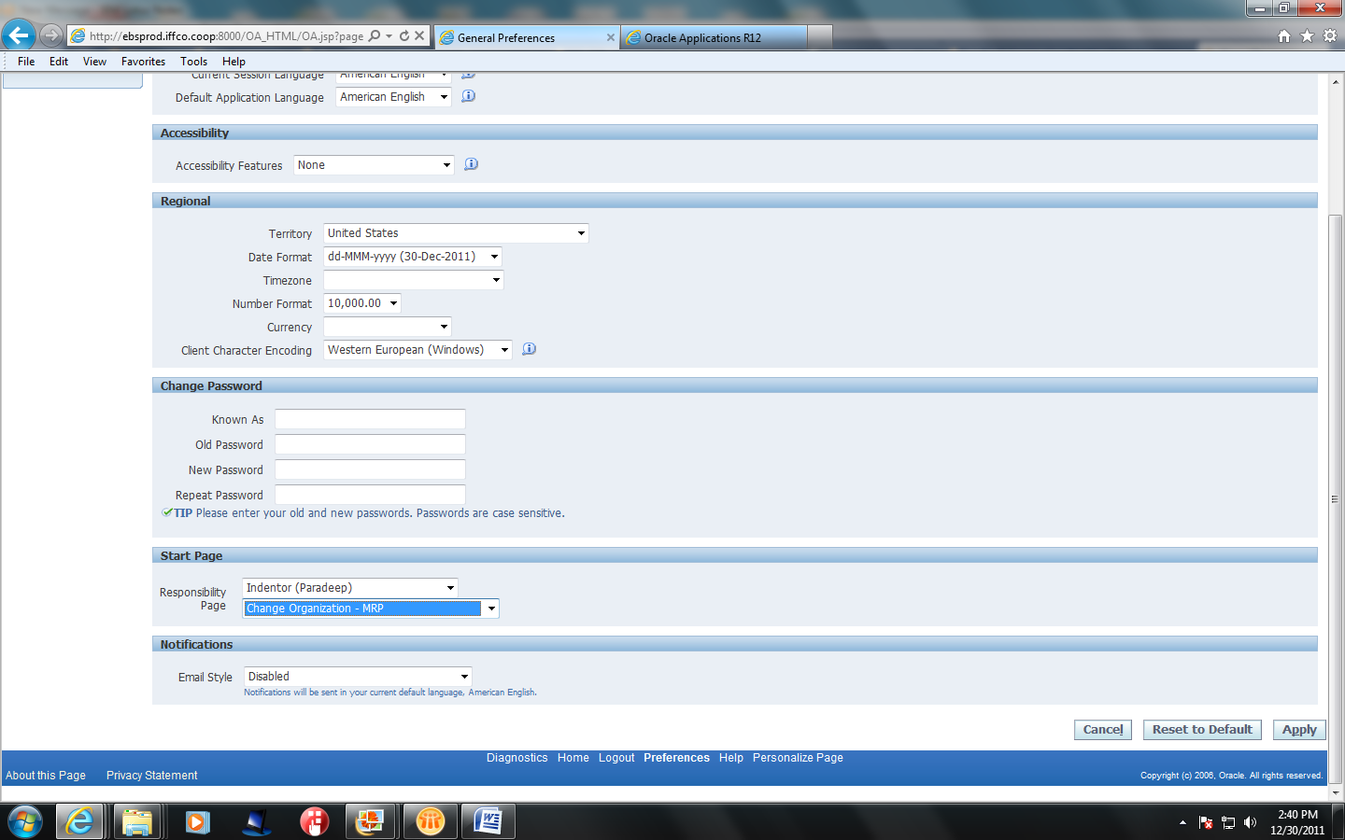
6. Logout and Login again . The application will be open in the form defined in the page.

