IFFCO CMD inaugurated Bio-fertilizer Plant at IFFCO Paradeep Unit 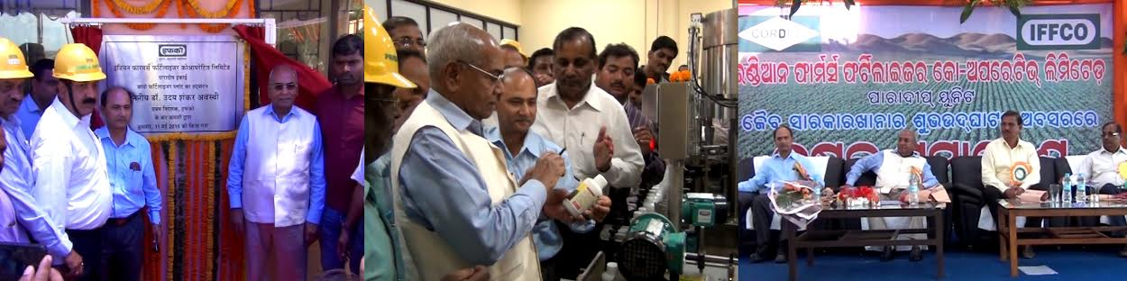
Report by Odisha Diary bureau, Paradeep: Bio-fertilizer Plant, 8th Evaporator in Phosphoric Acid Plant, Revamping of Sulphur Silo have been inaugurated by Dr. U.S.Awasthi, the CEO and Managing Director of Indian Farmers Fertiliser Coop. Ltd. (IFFCO) on 11th May, 2016 in the IFFCO Plant premises with the presence of farmers and other Senior Officers of IFFCO. On this occasion, the CEO & MD Dr. U.S. Awasthi has addressed the large gathering of farmers and made them understood about the utilization of Bio-fertilizer and its kind, usage and application. During his speech, he added that IFFCO supply the complex fertilizer of 38% of the total requirement of the country and said that all this production is possible because of the tireless efforts of employees and dedication contributed by each and every employee. He has appreciated the efforts put in by the employees and other concerned officials to stand with the farmers since its inception and we are committed to serve the farmers in the years to come also. He expressed his satisfaction for completion of Bio-Fertiliser Plant at Paradeep Unit before scheduled time. He also urge upon the farmers to give new idea which may give better result and requested farmers to take care of mother earth by reducing use of urea and balanced use of fertilizers. The CEO-cum-MD has expressed that a Farmers Training Centre will be constructed within a period of 6 months and by this Training Centre the farmers of Odisha will get benefit where their stay arrangements and all the updated electronic facilities will be provided. On this occasion, Shri. A.K. Panda, Unit Head of Paradeep Plant in his key note address, spoke about various progresses of Paradeep Unit and its success. He expressed that the Bio-Fertilisers Plant has been successfully completed within 10 months with a cost of Rs.4.00crores having capacity of 1 lac ltrs. Per annum. Shri. S.Chattopadhyay, State Mktg. Manager, Odisha has also addressed the gathering and explained about the usage of Bio-fertilizers and it’s benefits to the farmers. Dr.Manmath Prasad of CORDET in his address gave new dimensions to the Bio-Fertiliser Plant. On this occasion, the President & Secretary of IFFCO Employees’ Union and IFFCO Officers’ Association were also present and witnessed the inaugural functions. Sh.G.C.Acharya, Chief Manager (HR) finally gave vote of thanks to Hon’ble MD, Unit Head and all officials of IFFCO, Union & Association and the gatherings.

