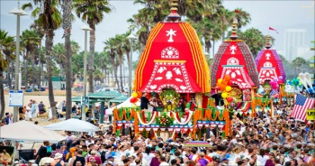
जय जगन्नाथ : अयमारंभ शुभाय भबतू : जय जगन्नाथ
Dear All,
The puja programme to mark the beginning of preparation for celebration of Grand Rath Yatra in our IFFCO Township will be held on 8th and 10th February,2019.

On this Occasion all are requested to attend the Puja Programme as per the given schedule.

Date Time Event

08.02.2019 6.00 AM Visit to Puri For “ Agyan Mala” by Kirtan Mandali
08.02.2019 8.00 PM Receiving of Agyan Mala at our Jagannath Temple
with a procession from Gate No-1.

10.02.2019 6.00 AM Kalasha puja at temple & Agyan Mala taken from
Mandir to Khala “the wood Yard “after necessary rituals.

7.00 AM Kalasha Puja, Panchanga Karma ,Laxmi Nrusingha Puja,Vastu Puja, Bhumi & Area Sodhan, Asta kula Naga puja, Viswakarma Puja, Varuna Puja ,Astadasa matrugana puja etc at Khala (Wood Yard ) followed by Havan Karma
8.50 AM Purnahuti , Puspanjali & Shanti Patha
9.05 AM Ratha Subha Anukula
9.15 AM onwards Prasad distribution

