Steps for creating OSL receipts

The OSL receipts can be entered from 18-Mar-2024 with the receipt date preferably as 23-Mar-2025 (Sunday) in all the cases of OSL, for clear identification of the OSL receipts.

Please follow the following steps for preparing OSL Receipt.

The receipt date has to be changed to 23-Mar-2025 as shown below in the screen shot.

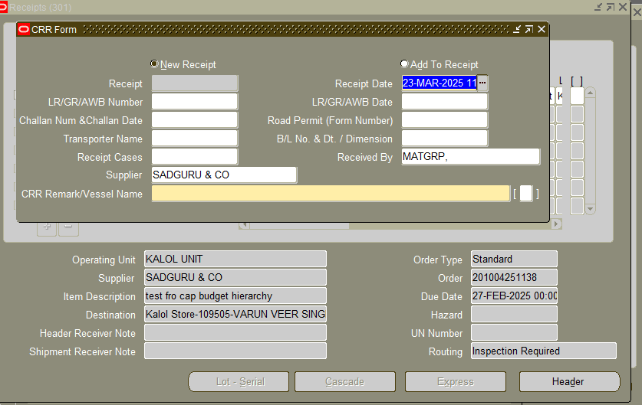

The OSL (2024-2025) to be entered in Handling Contractor Bill Number & Date Column provided in DFF. The screenshot has been attached below.

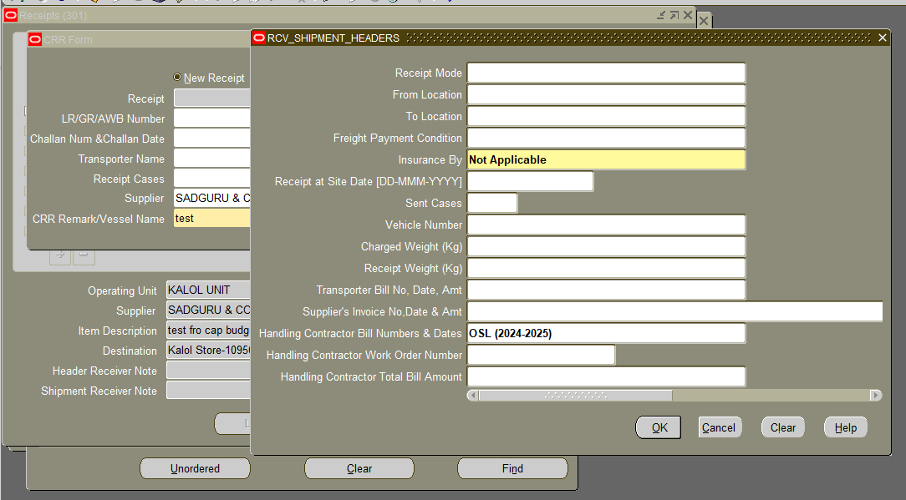

**Send the OSL receipt for Valuation:**

**Steps for Accounts User:-**

Please enter **Supplier Invoice Number** as OL|SRV Number

e.g. for SRV number 2020062201575 enter OL2020062201575 as invoice number.

Please enter **Supplier Invoice Date** as 23-Mar-2025

Users must delete all GST taxes from the receipt which have defaulted from Purchase Order.

Please do not delete other taxes. Confirm Taxes.

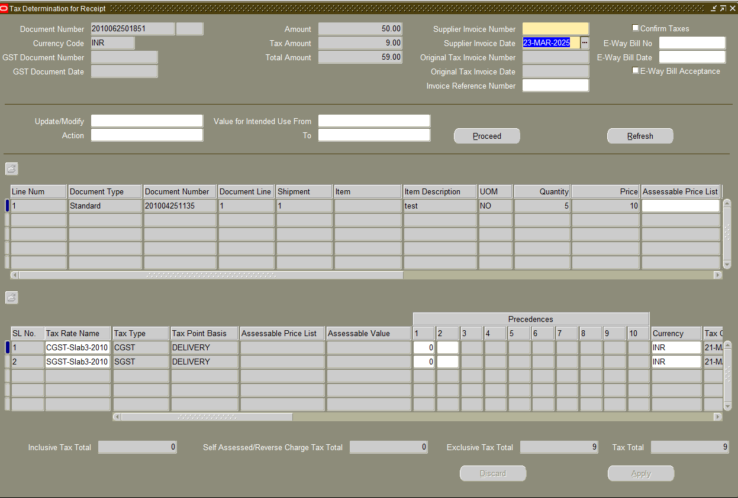

Make sure to **modify the date as** 23-Mar-2025 under **detail tab at the time of accepting the receipt.** The screenshot is attached.

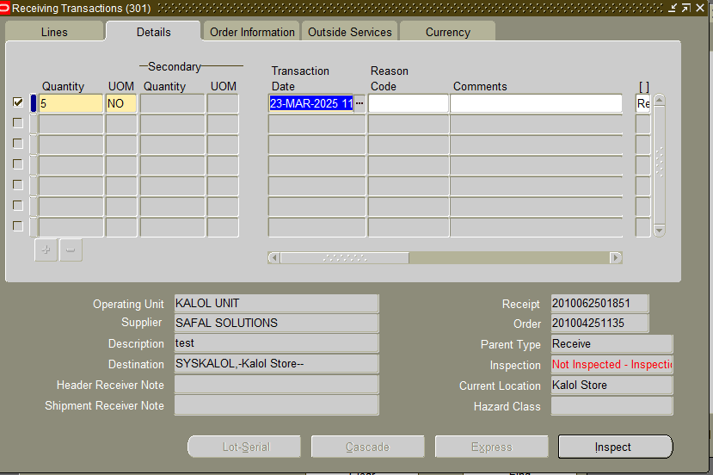

Go to Inspect button

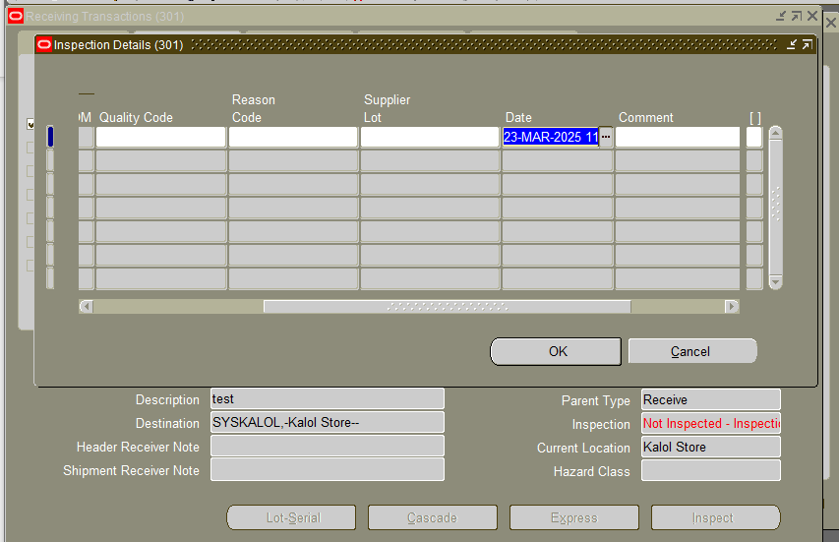

Put the Date as 23-Mar-2025 and Press OK and save the document

Please make sure to **modify the transaction date as** 23-Mar-2025 under detail tab **at the time of delivery of the receipt.** The screenshot is attached.

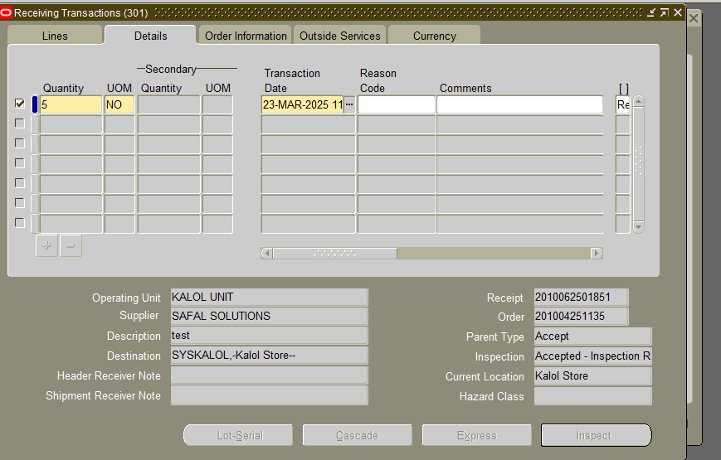

Hand-over the **OSL receipts to the accounts.**