INDIAN FARMERS FERTILISERS COOPERATIVE LIMITED
IFFCO, PARADEEP UNIT
02/03/2024.
CIRCULAR
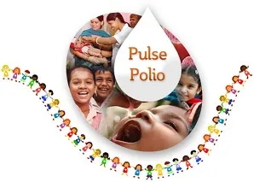
National Pulse Polio Immunization program - March 2024.
Children in the age group of 0-5yrs will be administered Polio drops during this campaign which will be held from 03/03/2024 to 05/03/2024. This is a mission by Govt. of India to eliminate Poliomyelitis from India by vaccination of all children under the age of 5yrs. This project fights Polio through a large-scale, Pulse vaccination program.

The schedule is as follows:

Date: 03/03/2024 to 05/03/2024.
Venue: IFFCO Township Hospital
Time: 08 AM ----- 04 PM.

Dr. Puspa Mohanthy.
DGM (M & HS)

