Steps for creating OSL receipts
The OSL receipts can be prepared from 18-Mar-2024 with the receipt date preferably as 17-Mar-2024 (Sunday) in all the cases of OSL, for clear identification of the OSL receipts.

Please follow the below steps for preparing OSL Receipt.

The receipt date has to be changed to 17-Mar-2024 as shown below in the screenshot.
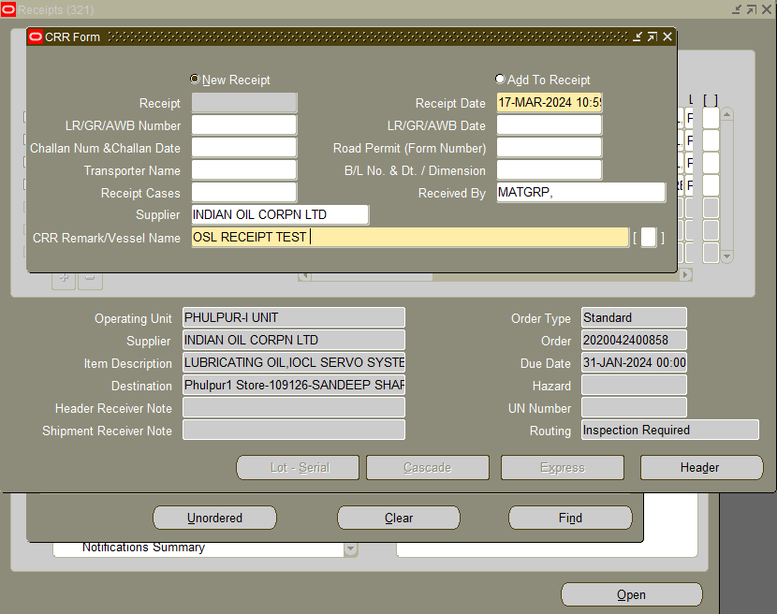

“ OSL (2023-2024) ” is to be entered in Handling Contractor Bill Number & Date Column provided in DFF. The screenshot has been given below.

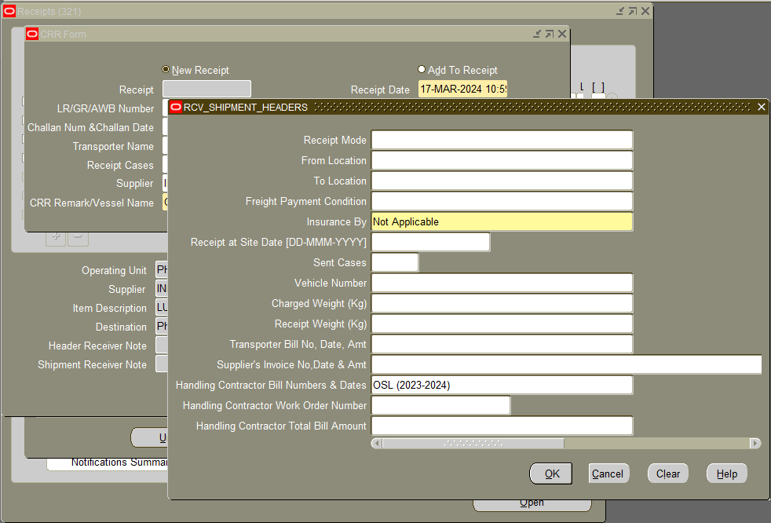

Send the OSL receipt for Valuation:

Steps for Accounts User:-

Please enter Supplier Invoice Number as OL|SRV Number
e.g. for SRV number 2020062201575 enter OL2020062201575 as invoice number.
Please enter Supplier Invoice Date as 17-Mar-2024

Users must delete all GST taxes from the receipt which have defaulted from Purchase Order.
Please do not delete other taxes. Confirm Taxes.
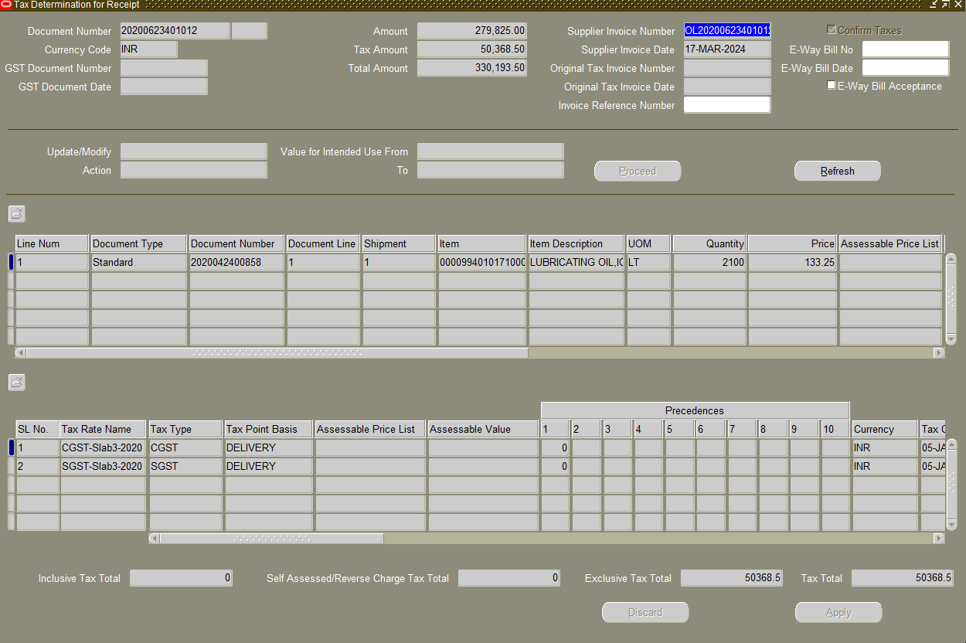

By Indentor:
Make sure to modify the date as 17-Mar-2024 under Details tab at the time of accepting the receipt. The screenshot is attached.

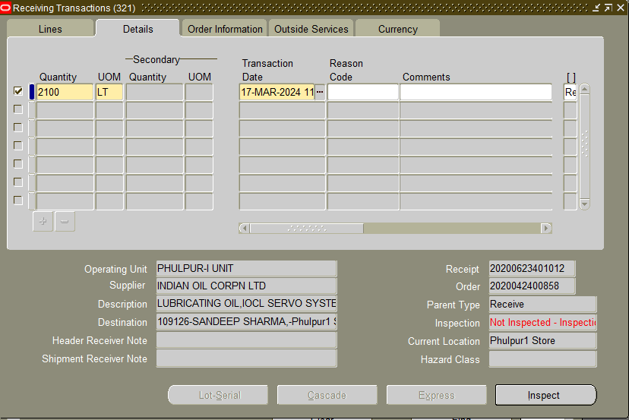

Go to Inspect button

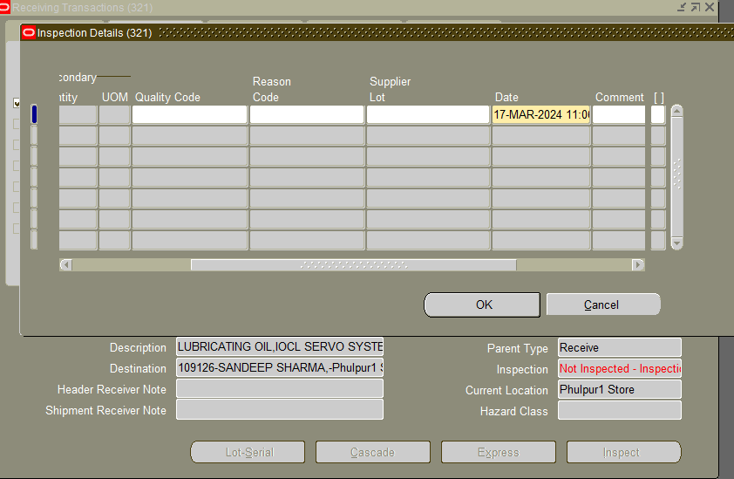

Put the Date as 17-Mar-2024 and Press OK and save the document

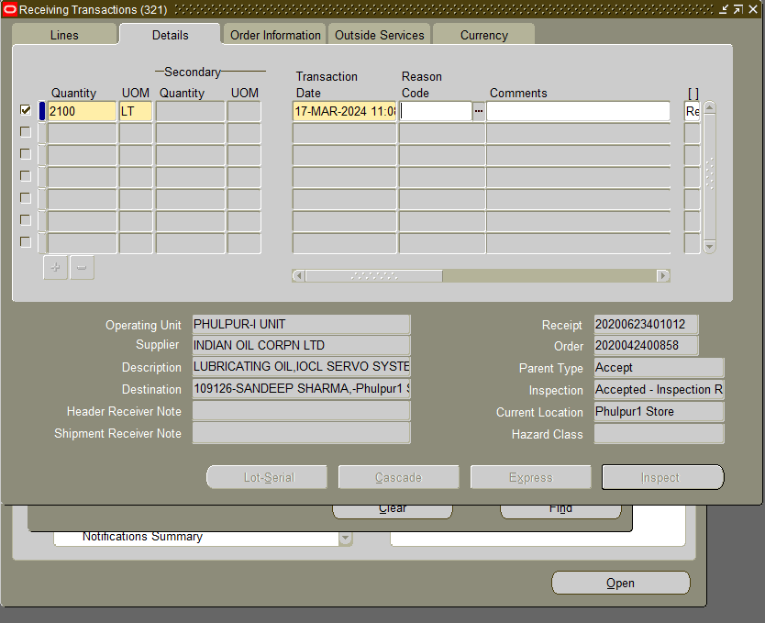

Please make sure to modify the transaction date as 17-Mar-2024 under Details tab at the time of delivery of the receipt. The screenshot is attached.

Hand-over the OSL receipts to the accounts.

