**Process to Apply IUCF Award online:**

Please log in to EIS >> Work Flow >> IUCF Award Claim

<https://eis.iffco.coop/WORKFLOW> -> IUCF Award Claim

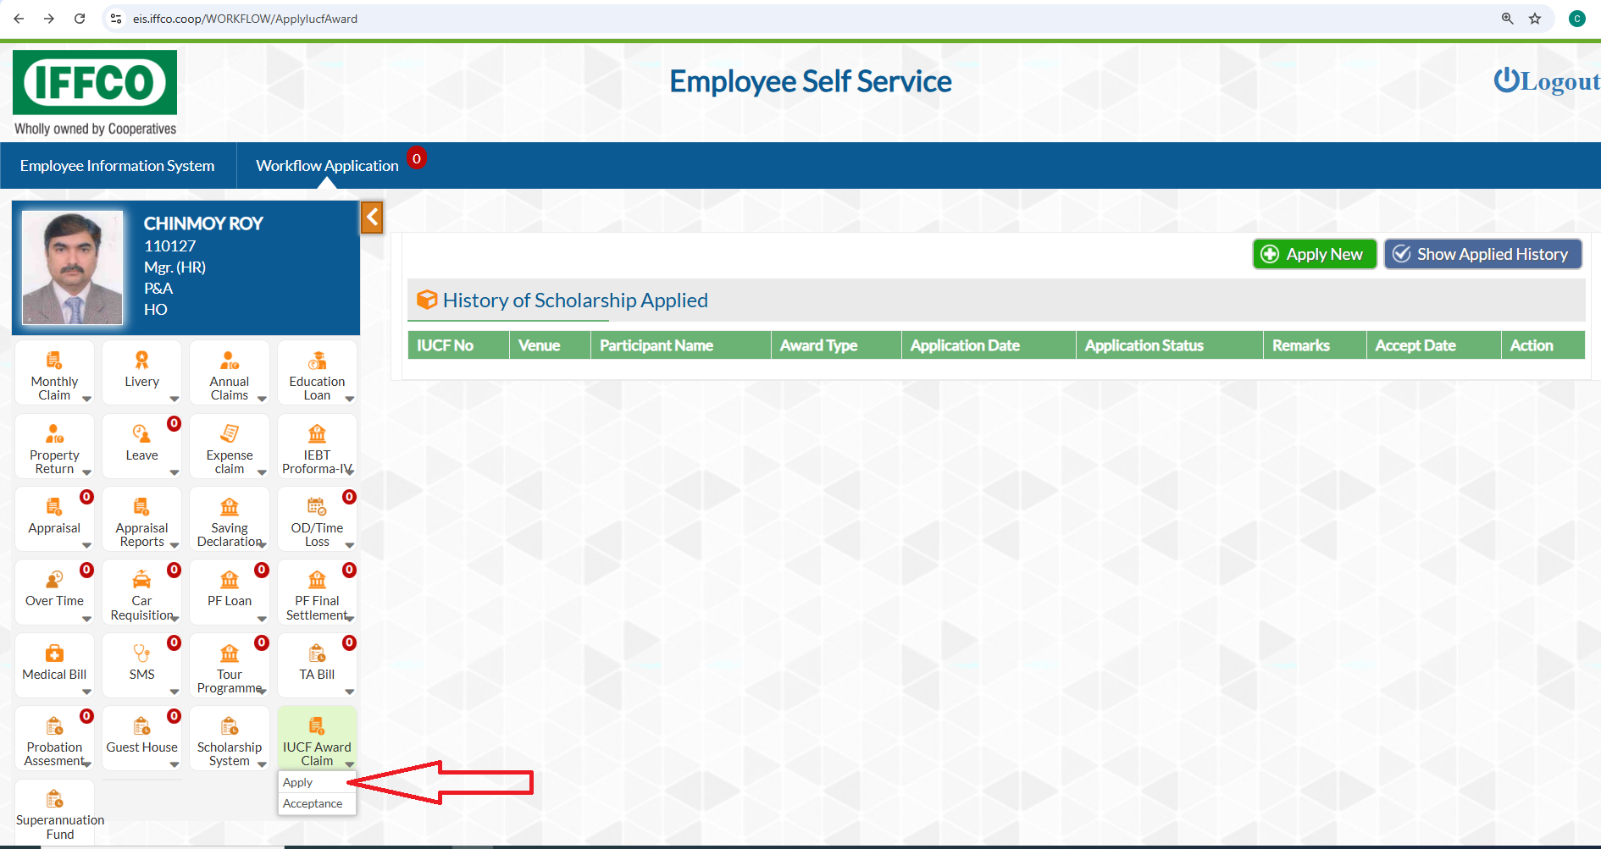

Click on Apply and then to Apply New.

You will be directed to the following screen. Where you will find your personal details and the name of your ward/s , who are eligible for the award of IUCF 2025.

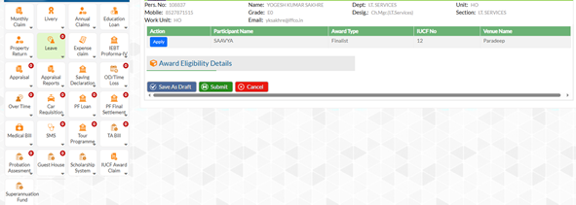

Now, click on apply against the name of your ward/s . Following screen will open to fill

1. Bank details of your Wards and upload the scanned copy of Cheque or Passbook Copy (well readable).
2. Enter the School / College / Institute name
3. Claim Entry : This has two parts ,
   1. Tuition Fees: Period for which you like to claim the Award, Amount of Tuition Fees. Then upload the Invoice / Bill of the Tuition Fees.
   2. Prize Value : Only fill the period for which you like to claim. Rest will follow automatically. No Attachment required in this case.
4. Fields are all mandatory. Having filled it properly, you may save it as Draft or can Submit.

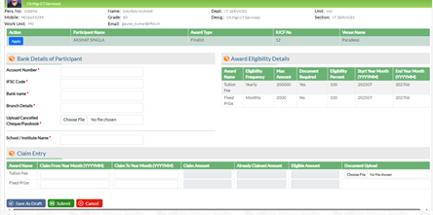

Following is the sample filled form..

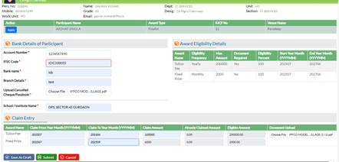

After submitting the Form, you need to take a print of the Form and submit it to P&A / HR along with the Copy of the cancelled Cheque and Original Invoice of Turion Fees.

